Supplementary Material

Equalisation of four cardiovascular risk algorithms after systematic re-calibration:
individual-participant meta-analysis of 86 prospective studies

The Emerging Risk Factors Collaboration
Contents list of supplementary material

Supplementary Appendices
Pages | eAppendix no.
2 | 1 |  | CVD risk prediction algorithms
3 | 2 |  | List of studies, abbreviations and references
9 | 3 |  | Supplementary statistical methods
Supplementary Tables
Pages | eTable  no.
11 | 1 | Summary of risk predictors used in each prediction algorithm
12 | 2 | Baseline characteristics of participating studies
14 | 3 | Endpoints used in derivation of each CVD risk prediction algorithms
15 | 4 | Baseline characteristics in participants with data available on Reynolds Risk Score
16 | 5 | Estimated public health impact with screening using original and recalibrated CVD risk prediction algorithms in 100,000 people aged 40-79 years without diabetes or LDL cholesterol>190mg/dL.
17 | 6 | Net Reclassification Improvement when using different algorithms before and after re-calibration

Supplementary Figures
Pages | eFigure  no.
18 | 1 | Methods used for recalibration of risk scores
19 | 2 | Discrimination abilities of original versions of risk prediction algorithms compared with the Framingham risk score, by sex and geographical region
20 | 3 | Discrimination abilities of original versions of risk prediction algorithms compared with the Framingham risk score, in the subset of participants with data available on Reynolds Risk Score
21 | 4 | C-index by median baseline year of recruitment
22 | 5 | Observed and predicted 10-year cardiovascular risk using original versions of prediction algorithms, in the subset of participants with data available on Reynolds Risk Score
23 | 6 | Observed and predicted cardiovascular risk and the absolute difference between them, by age and sex
24 | 7 | Heterogeneity among studies and algorithms in degree of mis-calibration: study specific ratio of predicted/observed 10-year CVD risk using original versions of each algorithm, plotted against study specific observed risk, by sex
25 | 8 | Study specific observed and predicted 10-year cardiovascular risk using original version of prediction algorithms
26 | 9 | Study specific ratio of predicted/observed 10-year cardiovascular risk using each algorithm, by sex, geographical region and year of baseline screening
27 | 10 | Distribution of 10-year predicted cardiovascular risk before and after recalibration
28 | 11 | Observed and predicted 10-year cardiovascular risk after recalibration
29 | 12 | Overlap in those classified as high risk according when applying all four CVD risk prediction algorithms to a US standard population of 100,000 individuals
30 | 13 | Similarity in individual risk predictions with different scores before and after re-calibration

Appendix 1. CVD risk prediction algorithms

Framingham risk score (FRS): Circulation 2008;117:743-753 |  |  | Authors recommend use of a conversion factor to adjust risk estimates to be for Hard CVD (Non-fatal MI or CHD death, or fatal or non-fatal stroke):  10-year estimate multiplied by 0.525 for men and 0.377 for women
Model details: separate Cox proportional hazards models for men and women.
Outcomes: coronary death, MI, angina, ischemic stroke, haemorragic stroke, TIA, PAD, HF
 | Men | Women
Risk predictors | Coefficients
Log(age) | 3.06117 | 2.32888
Smoking status | 0.65451 | 0.52873
Log(Tchol) | 1.1237 | 1.20904
Log(HDL) | -0.93263 | -0.70833
Log(SBP)if treated | 1.99881 | 2.82263
Log(SBP)if not treated | 1.93303 | 2.76157
Diabetes status | 0.57367 | 0.69154
Further values used in 10-year risk estimation
Baseline S0 | 0.88936 | 0.95012
Baseline Σ_{i}β_{i}X_{i} | 23.9802 | 26.1931

Systematic COronary Risk Evaluation (SCORE) Eur Heart J 2003;24:987-1003, and additional information from authors
Model details: Weibull PH model stratified by cohort and sex. Risk of CHD and Non-CHD are modelled separately.
Outcomes: Fatal CHD: ICD9: 410-414, Fatal non-CHD CVD: ICD9: 401-409, 426-443 (exc. 426.7, 429.0, 430.0, 432.1, 437.3, 437.4, 437.5), 798.1, 798.2
Risk predictors |  | Coefficients
 |  | CHD |  | Non-CHD CVD
Age |  | Used as the timescale in the Weibull models
Smoking status |  | 0.62 |  | 0.68
Total/HDL cholesterol |  | 0.3 |  | 0.04
Systolic BP(mmHg) |  | 0.017 |  | 0.019
Further values used in 10-year risk estimation
Weibull parameters |  | Scale (α) | Shape(p) | Scale (α) | Shape (p)
 | Low risk Men | -22.2 | 4.72 | -27.1 | 5.76
 | Low risk Women | -29.5 | 6.31 | -34.9 | 7.60
 | High risk Men | -21.3 | 4.68 | -26.9 | 5.79
 | High risk Women | -28.6 | 6.25 | -34.7 | 7.62

Pooled cohort equations (PCE) Circulation 2014:129(25 Suppl 2):S74-5.
Model details: separate Cox proportional hazards models for men and women.
Outcomes: Non-fatal MI or CHD death, or fatal or non-fatal stroke
Risk predictors | Coefficients
 | White |  | African American
 | Men | Women | Men | Women
Ln (age) | 12.344 | -29.799 | 2.469 | 17.114
Ln (age) squared | N/A | 4.884 | N/A | N/A
Smoking status | 7.837 | 7.574 | 0.549 | 0.691
Ln(age) x smoking status | -1.795 | -1.665 | N/A | N/A
Ln(total cholesterol) | 11.853 | 13.540 | 0.302 | 0.940
Ln(age) x ln(total cholesterol) | -2.664 | -3.114 | N/A | N/A
Ln(HDL-C) | -7.990 | -13.578 | -0.307 | -18.920
Ln(age) x ln(HDL-C) | 1.769 | 3.149 | N/A | 4.475
Ln (treated SBP) | 1.797 | 2.019 | 1.916 | 29.291
Ln (age) x ln (treated SBP) | N/A | N/A | N/A | -6.432
Ln (untreated SBP) | 1.764 | 1.957 | 1.809 | 27.820
Ln (age) x ln (untreated SBP) | N/A | N/A | N/A | -6.087
Diabetes status | 0.658 | 0.661 | 0.645 | 0.874
Further values used in 10-year risk estimation
Baseline Survival | 0.9144 | 0.9665 | 0.8954 | 0.9533
Mean coefficient value | 61.18 | -29.18 | 19.54 | 86.61

Reynolds Risk Score (RRS) Women: JAMA 2007; 297:611-619, Men: Circulation 2008; 118: 2243
Model details: separate Cox proportional hazards models for men and women.
Outcomes: myocardial infarction, ischemic stroke, coronary revascularization, and cardiovascular deaths
Risk predictors |  | Coefficients
 |  | Men |  | Women
age |  |  |  | 0.0799
log(age) |  | 4.385
Smoking status |  | 0.405 |  | 0.818
Log(Tchol) |  | 0.963 |  | 1.382
Log(HDL) |  | -0.772 |  | -1.172
SBP |  | 2.607 |  | 3.137
log(hsCRP) |  | 0.102 |  | 0.18
HbA1c (if diabetic) |  |  |  | 0.134
Parental history of MI<60 yrs |  | 0.541 |  | 0.438
Further values used in 10-year risk estimation
Baseline S0 | 0.899 |  | 0.98634
Baseline Σ_{i}β_{i}X_{i} | 33.097 |  | 22.325

Appendix 2. List of studies and abbreviations
ARIC, Atherosclerosis Risk in Communities Study
AFTCAPS, Air Force/Texas Coronary Atherosclerosis Prevention Study
ATENA, cohort of Progetto CUORE
AUSDIAB, Australian Diabetes, Obesity and Lifestyle Study
BHS, Busselton Health Study
BRHS, British Regional Heart Study
BRUN, Bruneck Study
BWHHS, British Women's Heart and Health Study
CAPS, Caerphilly Prospective Study
CASTEL, Cardiovascular Study in the Elderly
CHARL, Charleston Heart Study
CHS, Cardiovascular Health Study
COPEN, Copenhagen City Heart Study
DESIR, Data from an Epidemiological Study on the Insulin Resistance Syndrome
DRECE, Diet and Risk of Cardiovascular Disease in Spain
DUBBO, Dubbo Study of the Elderly
EAS, Edinburgh Artery Study
EMOFRI, part of CUORE
EPESEBOS, The Established Populations for the Epidemiologic Study of the Elderly Studies, Boston
EPESEIOW, The Established Populations for the Epidemiologic Study of the Elderly Studies, Iowa
EPESENCA, The Established Populations for the Epidemiologic Study of the Elderly Studies, North Carolina
EPESENHA, The Established Populations for the Epidemiologic Study of the Elderly Studies, New Haven
EPICNOR, European Prospective Investigation of Cancer Norfolk Study
ESTHER, Epidemiologische Studie zu Chancen der Verhutung und optimierten Therapie chronischer Erkrankungen in der alteren Bevolkerung
FINE_FIN, Finland, Italy and Netherlands Elderly Study – Finland cohort
FINE_IT, Finland, Italy and Netherlands Elderly Study – Italian cohort
FINMARK, cohort of CONOR
FINRISK-92, Finrisk Cohort 1992
FINRISK-97, Finrisk Cohort 1997
FRAM, Framingham Study
FRAMOFF, Framingham Offspring Cohort
FUNAGATA, Funagata Study
GOH, The Glucose Intolerance, Obesity and Hypertension Study
GOLSTRUP, Golstrup Study
GOTO43, Göteborg 1943 Study
GOTOW, Population Study of Women in Göteborg, Sweden
GRIPS, Göttingen Risk Incidence and Prevalence Study
HCS, Hertfordshire Cohort Study
HIMS, Health in Men Study
HISAYAMA, Hisayama Study
HONOL, Honolulu Heart Program
HOORN, Hoorn Study
HUBRO, cohort of CONOR
IKNS, Ikawa, Kyowa, and Noichi Study
ISRAEL, Israeli Ischaemic Heart Disease Study
KAREL72, North Karelia Project
KIHD, Kuopio Ischaemic Heart Disease Study
LASA, Longitudinal Aging Study Amsterdam
LEADER, Lower Extremity Arterial Disease Event Reduction Trial
MPP, Malmö Preventive Project
MATISS-93, cohort of Progetto CUORE
MESA, Multi-Ethnic Study of Atherosclerosis
MCVDRFP, Monitoring of CVD Risk Factors Project
MIDFAM, MIDSPAN Family Study
MONICA_KORA2, MONICA/KORA Augsburg Surveys S2
MONICA_KORA3, MONICA/KORA Augsburg Surveys S3
MONFRI86, cohort of Progetto CUORE
MONFRI89, cohort of Progetto CUORE
MONFRI94, cohort of Progetto CUORE
MORGEN, Monitoring Project on Chronic Disease Risk Factors
MOSWEGOT, MONICA Göteborg Study
MRFIT, Multiple Risk Factor Intervention Trial 1
NCS, Norwegian Counties Studies
NHANES III, Third National Health and Nutrition Examination Survey
NPHSII, Northwick Park Heart Study II
NSHS, Nova Scotia Health Survey
OPPHED, cohort of CONOR
OSAKA, Osaka Study
OSLO, Oslo Study
OSLO2, cohort of CONOR
PARIS1, Paris Prospective Study I
PREVEND, Prevention of Renal and Vascular End Stage Disease Study
PRHHP, Puerto Rico Heart Health Program
PRIME, Prospective Epidemiological Study of Myocardial Infarction
PROCAM, Prospective Cardiovascular Münster Study
PROSPER, Prospective Study of Pravastatin in the Elderly at Risk
ProspectEPIC, Prospect-EPIC Utrecht
QUEBEC, Quebec Cardiovascular Study
RANCHO, Rancho Bernardo Study
RIFLE, Risk Factors and Life Expectancy Pooling Project
REYK, Reykjavik Study
RS_I, The Rotterdam Study I
RS_II, The Rotterdam Study II
SHHEC, Scottish Heart Health Extended Cohort
SHIP, Study of Health in Pomerania
SHS, Strong Heart Study
SPEED, Speedwell Study
TARFS, Turkish Adult Risk Factor Study
TOYAMA, Toyama Study
TROMS, cohort of CONOR
TROMSØ, Tromsø Study
ULSAM, Uppsala Longitudinal Study of Adult Men
USPHS2, U.S. Physicians Health Study 2
WHITE I, Whitehall I Study
WHITE II, Whitehall II Study
WCWC, Wurttemberg Construction Worker Cohort
WHS, Women’s Health Study
WOSCOPS, West of Scotland Coronary Prevention Study
ZARAGOZA, Zaragoza Study
ZUTE, Zutphen Elderly Study

ATHENA, EMOFRI, MONFRI86, MONFRI89, MONFRI94, and MATISS-93 are part of the CUORE study
FINNMARK, HUBRO, OPPHED, OSLO2, and TROMS are part of the CONOR study

References
- Lee CD, Folsom AR, Pankow JS, Brancati FL. Cardiovascular events in diabetic and nondiabetic adults with or without history of myocardial infarction. Circulation 2004;109:855-860.
- Downs JR, Beere PA, Whitney E, et al. Design & rationale of the Air Force/Texas Coronary Atherosclerosis Prevention Study (AFCAPS/TexCAPS). Am J Cardiol 1997;80:287-93.
(3) Palmieri L, Donfrancesco C, Giampaoli S et al. Favorable cardiovascular risk profile and 10-year coronary heart disease incidence in women and men: results from the Progetto CUORE. Eur J Cardiovasc Prev Rehabil 2006;13:562-570.
(4) Dunstan DW, Zimmet PZ, Welborn TA et al. The Australian Diabetes, Obesity and Lifestyle Study (AusDiab)--methods and response rates. Diabetes Res Clin Pract 2002;57:119-129.
(5) Knuiman MW, Vu HT. Prediction of coronary heart disease mortality in Busselton, Western Australia: an evaluation of the Framingham, national health epidemiologic follow up study, and WHO ERICA risk scores. J Epidemiol Community Health 1997;51:515-519.
(6) Wannamethee SG, Shaper AG, Lennon L. Cardiovascular disease incidence and mortality in older men with diabetes and in men with coronary heart disease. Heart 2004;90:1398-1403.
(7) Willeit J, Kiechl S. Prevalence and risk factors of asymptomatic extracranial carotid artery atherosclerosis. A population-based study. Arterioscler Thromb 1993;13:661-668.
(8) Lawlor DA, Bedford C, Taylor M, Ebrahim S. Geographical variation in cardiovascular disease, risk factors, and their control in older women: British Women's Heart and Health Study. J Epidemiol Community Health 2003;57:134-140.
(9) Bainton D, Miller NE, Bolton CH et al. Plasma triglyceride and high density lipoprotein cholesterol as predictors of ischaemic heart disease in British men. The Caerphilly and Speedwell Collaborative Heart Disease Studies. Br Heart J 1992;68:60-66.
(10) Casiglia E, Pauletto P, Mazza A et al. Impaired glucose tolerance and its co-variates among 2079 non-diabetic elderly subjects. Ten-year mortality and morbidity in the CASTEL study. CArdiovascular STudy in the ELderly. Acta Diabetol 1996;33:284-290.
(11) Nietert PJ, Sutherland SE, Keil JE, Bachman DL. Demographic and biologic influences on survival in whites and blacks: 40 years of follow-up in the Charleston Heart Study. Int J Equity Health 2006;5:8.
(12) Carnethon MR, Biggs ML, Barzilay J et al. Diabetes and coronary heart disease as risk factors for mortality in older adults. Am J Med 2010;123:556-559.
(13) Schnohr P, Jensen G, Nyboe J, Eybjaerg HA. [The Copenhagen City Heart Study. A prospective cardiovascular population study of 20,000 men and women]. Ugeskr Laeger 1977;139:1921-1923.
(14) Balkau B, Lange C, Fezeu L et al. Predicting diabetes: clinical, biological, and genetic approaches: data from the Epidemiological Study on the Insulin Resistance Syndrome (DESIR). Diabetes Care 2008;31:2056-2061.
(15) Ballesteros-Pomar MD, Rubio-Herrera MA, Gutierrez-Fuentes JA, et al. Dietary habits and cardiovascular risk in the Spanish population: the DRECE study (II) micronutrient intake. Dieta y Riesgo de Enfermedades Cardiovasculares en Espana. Ann Nutr Metab 2000;44:177-82.
(16) Simons LA, Simons J, Friedlander Y, McCallum J. Usefulness of fasting plasma glucose to predict mortality or coronary heart disease in persons > or = 60 years of age without diabetes mellitus or in those with undiagnosed diabetes mellitus (from The Dubbo Study). Am J Cardiol 2008;102:831-834.
(17) Fowkes FG, Housley E, Cawood EH, Macintyre CC, Ruckley CV, Prescott RJ. Edinburgh Artery Study: prevalence of asymptomatic and symptomatic peripheral arterial disease in the general population. Int J Epidemiol 1991;20:384-392.
(18) Cornoni-Huntley J, Ostfeld AM, Taylor JO et al. Established populations for epidemiologic studies of the elderly: study design and methodology. Aging (Milano ) 1993;5:27-37.
(19) Day N, Oakes S, Luben R et al. EPIC-Norfolk: study design and characteristics of the cohort. European Prospective Investigation of Cancer. Br J Cancer 1999;80 Suppl 1:95-103.
(20) Schöttker B, Haug U, Schomburg L, Köhrle J, Perna L, Müller H, Holleczek B, Brenner H. Strong associations of 25-hydroxyvitamin D concentrations with all-cause, cardiovascular, cancer, and respiratory disease mortality in a large cohort study. Am J Clin Nutr 2013;97:782-793.
(21) Menotti A, Mulder I, Nissinen A et al. Cardiovascular risk factors and 10-year all-cause mortality in elderly European male populations; the FINE study. Finland, Italy, Netherlands, Elderly. Eur Heart J 2001;22:573-579.
(22) Rabanal KS, Lindman AS, Selmer RM, Aamodt G. Ethnic differences in risk factors and total risk of cardiovascular disease based on the Norwegian CONOR study. Eur J Prev Cardiol 2012.
(23) Laatikainen T, Critchley J, Vartiainen E, Salomaa V, Ketonen M, Capewell S. Explaining the decline in coronary heart disease mortality in Finland between 1982 and 1997. Am J Epidemiol 2005;162:764-773.
(24) Kannel WB, McGee D, Gordon T. A general cardiovascular risk profile: the Framingham Study. Am J Cardiol 1976;38:46-51.
(25) Rutter MK, Meigs JB, Sullivan LM, D'Agostino RB Sr, Wilson PW. C-reactive protein, the metabolic syndrome, and prediction of cardiovascular events in the Framingham Offspring Study. Circulation 2004;110:380-385.
(26) Sekikawa A, Eguchi H, Tominaga M, et al. Prevalence of type 2 diabetes mellitus and impaired glucose tolerance in a rural area of Japan. The Funagata diabetes study. J Diabetes Complications 2000;14:78-83.
(27) Modan M, Halkin H, Karasik A, Lusky A. Effectiveness of glycosylated hemoglobin, fasting plasma glucose, and a single post load plasma glucose level in population screening for glucose intolerance. Am J Epidemiol 1984;119:431-44.
(28) Sjol A, Grunnet K, Schroll M. Secular trends in serum cholesterol, high density lipoproteins and triglycerides 1964-1987. Int J Epidemiol 1991;20:105-13.
(29) Rosengren A, Eriksson H, Larsson B et al. Secular changes in cardiovascular risk factors over 30 years in Swedish men aged 50: the study of men born in 1913, 1923, 1933 and 1943. J Intern Med 2000;247:111-118.
(30) Noppa H, Bengtsson C. Obesity in relation to smoking: a population study of women in Göteborg, Sweden. Prev Med 1980;9:534-543.
(31) Cremer P, Elster H, Labrot B, Kruse B, Muche R, Seidel D. Incidence rates of fatal and nonfatal myocardial infarction in relation to the lipoprotein profile: first prospective results from the Gottingen Risk, Incidence, and Prevalence Study (GRIPS). Klin Wochenschr 1988;66 Suppl 11:42-49.
(32) Syddall HE, Aihie Sayer A, Dennison EM, Martin HJ, Barker DJ, Cooper C. Cohort profile: the Hertfordshire cohort study. Int J Epidemiol 2005;34:1234-1242.
(33) Norman PE, Flicker L, Almeida OP, Hankey GJ, Hyde Z, Jamrozik K. Cohort Profile: The Health In Men Study (HIMS). Int J Epidemiol 2009;38:48-52.
(34) Kubo M, Kiyohara Y, Kato I, et al. Trends in the incidence, mortality, and survival rate of cardiovascular disease in a Japanese community: the Hisayama study. Stroke 2003;34:2349-54.
(35) Kagan A, Popper JS, Rhoads GG. Factors related to stroke incidence in Hawaii Japanese men. The Honolulu Heart Study. Stroke 1980;11:14-21.
(36) Mooy JM, Grootenhuis PA, de VH et al. Prevalence and determinants of glucose intolerance in a Dutch caucasian population. The Hoorn Study. Diabetes Care 1995;18:1270-1273.
(37) Iso H, Naito Y, Sato S, Kitamura A, Okamura T, Sankai T, Shimamoto T, Iida M, Komachi Y. Serum triglycerides and risk of coronary heart disease among Japanese men and women. Am J Epidemiol 2001;153:490-499.
(38) Goldbourt U, Medalie JH. High density lipoprotein cholesterol and incidence of coronary heart disease--the Israeli Ischemic Heart Disease Study. Am J Epidemiol 1979;109:296-308.
(39) Vartiainen E, Puska P, Jousilahti P, Korhonen HJ, Tuomilehto J, Nissinen A. Twenty-year trends in coronary risk factors in north Karelia and in other areas of Finland. Int J Epidemiol 1994;23:495-504.
(40) Salonen, JT, Salonen, R; Seppanen, K; Rauramaa, R; Tuomilehto, J. HDL, HDL2, and HDL3 Subfractions, and the Risk of Acute Myocardial Infarction. A Prospective Population Study in Eastern Finnish Men. Circulation 1991; 84:129-139.
(41) Huisman M, Poppelaars J, van der Horst M, Beekman AT, Brug J, van Tilburg TG, Deeg DJ. Cohort profile: the Longitudinal Aging Study Amsterdam. Int J Epidemiol 2011;40:868-876.
(42) Meade TW. Design and intermediate results of the Lower Extremity Arterial Disease Event Reduction (LEADER)* trial of bezafibrate in men with lower extremity arterial disease [ISRCTN4119421]. Curr Control Trials Cardiovasc Med 2001;2:195-204.
(43) Berglund G, Eriksson KF, Israelsson B, Kjellström T, Lindgärde F, Mattiasson I, Nilsson JA, Stavenow L. Cardiovascular risk groups and mortality in an urban swedish male population: the Malmö Preventive Project. J Intern Med 1996;239:489-497.
(44) Bild DE, Bluemke DA, Burke GL, et al. Multi-Ethnic Study of Atherosclerosis: objectives and design. Am J Epidemiol 2002;156:871-81.
(45) Hoeymans N, Smit HA, Verkleij H, Kromhout D. Cardiovascular risk factors in relation to educational level in 36 000 men and women in The Netherlands. Eur Heart J 1996;17:518-525.
(46) Welsh P, Doolin O, McConnachie A, Boulton E, McNeil G, Macdonald H, Hardcastle A, Hart C, Upton M, Watt G, Sattar N. Circulating 25OHD, dietary vitamin D, PTH, and calcium associations with incident cardiovascular disease and mortality: the MIDSPAN Family Study. J Clin Endocrinol Metab 2012;97:4578-4587.
(47) Keil U, Liese AD, Hense HW et al. Classical risk factors and their impact on incident non-fatal and fatal myocardial infarction and all-cause mortality in southern Germany. Results from the MONICA Augsburg cohort study 1984-1992. Monitoring Trends and Determinants in Cardiovascular Diseases. Eur Heart J 1998;19:1197-1207.
(48) Houterman S, Verschuren WM, Oomen CM, Boersma-Cobbaert CM, Kromhout D. Trends in total and high density lipoprotein cholesterol and their determinants in The Netherlands between 1993 and 1997. Int J Epidemiol 2001;30:1063-1070.
(49) Wilhelmsen L, Johansson S, Rosengren A, Wallin I, Dotevall A, Lappas G. Risk factors for cardiovascular disease during the period 1985-1995 in Goteborg, Sweden. The GOT-MONICA Project. J Intern Med 1997;242:199-211.
(50) Sherwin R, Kaelber CT, Kezdi P, Kjelsberg MO, Thomas HE Jr. The multiple risk factor intervention trial (MRFIT) II. The development of the protocol. Prev Med 1981;10:402-425.
(51) Bjartveit K, Foss OP, Gjervig T. The cardiovascular disease study in Norwegian counties. Results from first screening. Acta Med Scand Suppl 1983;675:1-184.
(52) Muntner P, He J, Chen J, Fonseca V, Whelton PK. Prevalence of non-traditional cardiovascular disease risk factors among persons with impaired fasting glucose, impaired glucose tolerance, diabetes, and the metabolic syndrome: analysis of the Third National Health and Nutrition Examination Survey (NHANES III). Ann Epidemiol 2004;14:686-95.
(53) Cooper JA, Miller GJ, Bauer KA, et al. Comparison of novel hemostatic factors and conventional risk factors for prediction of coronary heart disease. Circulation 2000;102:2816-22.
(54) Davidson KW, Schwartz JE, Kirkland SA, Mostofsky E, Fink D, Guernsey D, Shimbo D. Relation of inflammation to depression and incident coronary heart disease (from the Canadian Nova Scotia Health Survey [NSHS95] Prospective Population Study). Am J Cardiol 2009;103:755-761.
(55) Kitamura A, Sato S, Kiyama M et al. Trends in the incidence of coronary heart disease and stroke and their risk factors in Japan, 1964 to 2003: the Akita-Osaka study. J Am Coll Cardiol 2008;52:71-79.
(56) Haheim LL, Holme I, Hjermann I, Leren P, Tonstad S. Trends in the incidence of acute myocardial infarction and stroke: a 21-year follow-up of the Oslo study. Scand Cardiovasc J 2004;38:216-221.
(57) Ducimetiere P, Richard JL, Cambien F, Rakotovao R, Claude JR. Coronary heart disease in middle-aged Frenchmen. Comparisons between Paris Prospective Study, Seven Countries Study, and Pooling Project. Lancet 1980;1:1346-50.
(58) Geluk CA, Tio RA, Tijssen JG et al. Clinical characteristics, cardiac events and coronary angiographic findings in the prospective PREVEND cohort: an observational study. Neth Heart J 2007;15:133-141.
(59) Garcia-Palmieri MR, Feliberti M, Costas R, Jr. et al. An epidemiological study on coronary heart disease in PR. The Puerto Rico Heart Health Program. 1969. Bol Asoc Med P R 2002;94:61-67.
(60) Ducimetiere P, Ruidavets JB, Montaye M, Haas B, Yarnell J. Five-year incidence of angina pectoris and other forms of coronary heart disease in healthy men aged 50-59 in France and Northern Ireland: the Prospective Epidemiological Study of Myocardial Infarction (PRIME) Study. Int J Epidemiol 2001;30:1057-1062.
(61) Assmann G, Cullen P, Schulte H. Simple scoring scheme for calculating the risk of acute coronary events based on the 10-year follow-up of the prospective cardiovascular Munster (PROCAM) study. Circulation 2002;105:310-315.
(62) Shepherd J, Blauw GJ, Murphy MB et al. The design of a prospective study of Pravastatin in the Elderly at Risk (PROSPER). PROSPER Study Group. PROspective Study of Pravastatin in the Elderly at Risk. Am J Cardiol 1999;84:1192-1197.
(63) Boker LK, van Noord PA, van der Schouw YT et al. Prospect-EPIC Utrecht: study design and characteristics of the cohort population. European Prospective Investigation into Cancer and Nutrition. Eur J Epidemiol 2001;17:1047-1053.
(64) Dagenais GR, Robitaille NM, Lupien PJ et al. First coronary heart disease event rates in relation to major risk factors: Quebec cardiovascular study. Can J Cardiol 1990;6:274-280.
(65) Barrett-Connor E. The Rancho Bernardo Study: 40 years studying why women have less heart disease than men and how diabetes modifies women's usual cardiac protection. Glob Heart 2013;8:95-104.
(66) The RIFLE Research Group. Presentation of the rifle project risk factors and life expectancy. The RIFLE Research Group. Eur J Epidemiol 1993;9:459-476.
(67) Sigurdsson E, Thorgeirsson G, Sigvaldason H, Sigfusson N. Prevalence of coronary heart disease in Icelandic men 1968-1986. The Reykjavik Study. Eur Heart J 1993;14:584-91.
(68) Hofman A, Darwish Murad S, van Duijn CM, Franco OH, Goedegebure A, Ikram MA, Klaver CC, Nijsten TE, Peeters RP, Stricker BH, Tiemeier HW, Uitterlinden AG, Vernooij MW. The Rotterdam Study: 2014 objectives and design update. Eur J Epidemiol 2013;28:889-926.
(69) Smith WC, Crombie IK, Tavendale R, Irving JM, Kenicer MB, Tunstall PH. The Scottish Heart Health Study: objectives and development of methods. Health Bull (Edinb ) 1987;45:211-217.
(70) Kowall B, Rathmann W, Giani G et al. Random glucose is useful for individual prediction of type 2 diabetes: results of the Study of Health in Pomerania (SHIP). Prim Care Diabetes 2013;7:25-31.
(71) Lee ET, Welty TK, Fabsitz R, Cowan LD, Le NA, Oopik AJ, Cucchiara AJ, Savage PJ, Howard BV. The Strong Heart Study. A study of cardiovascular disease in American Indians: design and methods. Am J Epidemiol 1990;132:1141-1155.
(72) Onat A, Senocak MS. Relative risk of factors for coronary heart disease in population with low cholesterol levels. Int J Cardiol 1994;43:51-60.
(73) Stamler J, Elliott P, Dennis B, et al. INTERMAP: background, aims, design, methods, and descriptive statistics (nondietary). J Hum Hypertens 2003;17:591-608.
(74) Miller NE, Thelle DS, Forde OH, Mjos OD. The Tromso heart-study. High-density lipoprotein and coronary heart-disease: a prospective case-control study. Lancet 1977;1:965-968.
(75) Lind L, Vessby B, Sundstrom J. The apolipoprotein B/AI ratio and the metabolic syndrome independently predict risk for myocardial infarction in middle-aged men. Arterioscler Thromb Vasc Biol 2006;26:406-410.
(76) Christen WG, Gaziano JM, Hennekens CH. Design of Physicians' Health Study II--a randomized trial of beta-carotene, vitamins E and C, and multivitamins, in prevention of cancer, cardiovascular disease, and eye disease, and review of results of completed trials. Ann Epidemiol 2000;10:125-34.
(77) Reid DD, Brett GZ, Hamilton PJ, Jarrett RJ, Keen H, Rose G. Cardiorespiratory disease and diabetes among middle-aged male Civil Servants. A study of screening and intervention. Lancet 1974;1:469-73.
(78) Brunner EJ, Marmot MG, White IR, et al. Gender and employment grade differences in blood cholesterol, apolipoproteins and haemostatic factors in the Whitehall II study. Atherosclerosis 1993;102:195-207.
(79) Arndt V, Rothenbacher D, Brenner H, et al. Older workers in the construction industry: results of a routine health examination and a five year follow up. Occup Environ Med 1996;53:686-91.
(80) Ridker PM, Buring JE, Shih J, Matias M, Hennekens CH. Prospective study of C-reactive protein and the risk of future cardiovascular events among apparently healthy women. Circulation 1998;98:731-3.
(81) Shepherd J, Cobbe SM, Ford I, et al. Prevention of coronary heart disease with pravastatin in men with hypercholesterolemia. West of Scotland Coronary Prevention Study Group. N Engl J Med 1995;333:1301-7.
(82) Alejandro Marín Ibáñez, Mario Bárcena Caamaño, M. Victoria Fustero Fernández, Javier Tisaire Sánchez, José M. Cucalón Arenal, José S. González Ramos, José Bueno Gómez, Héctor Pintado Sandoval, Vicente Compaired Aragüés, Aurelio Martín Ruiz, Josep M. Sol Maurí, Francisco Hernansanz Iglesias, Manuel Amores Ferreras, Gonzalo Hernández Herrero. Risk Factors for Cardiovascular and Ischaemic Heart Disease in a Mediterranean Country: Preliminary Report of the Zaragoza Study (ZACARIS-I) Clin Drug Invest. 2002;22:4-15
(83) Weijenberg MP, Feskens EJ, Kromhout D. Total and high density lipoprotein cholesterol as risk factors for coronary heart disease in elderly men during 5 years of follow-up. The Zutphen Elderly Study. Am J Epidemiol 1996;143:151-8.

Appendix 3. Supplementary statistical methods

Assessment of calibration
Mean predicted and observed 10 year risks were calculated within five-year age categories ranging from 40-44 to 75-79 years. Mean observed 10-year CVD risk within each age category and study (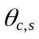 for category c in 1:C and study s in 1:S), was obtained using the following general Cox model:
S(t|c,s) = S_{0s}(t) ^{exp(β’c)} (1)
Where β is a vector, and c a set of (C-1) dummy variables representing the age categories, S(t|c,s) is the probability of not having a CVD event by time t given category c and study s, and S_{0s}(t) is the baseline survival function for study s. Observed category and study specific 10-year CVD risk was then estimated using the following translation:
= 1- S(10|c,s) = 1- S_{0s}(10) ^{exp(β’c)} (2)
This method assumes proportional hazards across categories, and the process was completed separately for men and women. Study specific estimates of observed risk in each category 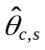 were pooled across studies weighting by the number of study and category specific contributing events:
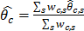 (3)
Calibration was then assessed by visual comparison of plots of the pooled predicted and observed risks and assessment of goodness of fit using methods previously proposed by Parzen and Lipsitz (Biometrics 1999;55:580-4).

Recalibration
Each of the assessed risk scores was mis-calibrated to some degree for the ERFC data. Re-calibration was completed within each study and sex, allowing the mean level and range of predicted risk to match that observed within each study and sex. A linear model was fit within each study to relate observed risk () and predicted risk (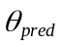) estimated for five-year age categories (c_{s}):
(4)
The estimated 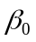 and 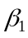 were then used to rescale each person’s original risk prediction 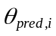 to give a new estimate  from the re-calibrated risk model as follows:
(5)
This method differs from that previously detailed by van Houwelingen (Stat Med 2000;19:3401-15) only in that categories are defined as age groups rather than deciles of predicted risk, which has the advantage of making it applicable to population age and sex specific statistics for event rates (observed risk) and risk factors values (see Figure 1). In addition, it can be used similarly for any structure of risk prediction equation (e.g. Weibull, Cox model etc).

eTable 1. Summary of risk predictors used in each prediction algorithm

Risk predictors included |  | SCORE  2003 | FRS  2008 | RRS for Women  (2007) | RRS for men  (2008) | PCE  (2013)
Traditional non-blood based risk factors
 | Age, sex, smoking, SBP | ü | ü | ü | ü | ü
Interview based
 | History of diabetes |  | ü |  |  | ü
 | Family history of CVD |  |  | ü | ü
 | Ethnicity |  |  |  |  | ü
Blood based measurements
 | Total cholesterol |  | ü | ü | ü | ü
 | HDL-C |  | ü | ü | ü | ü
 | Total/HDL cholesterol | ü
 | CRP |  |  | ü | ü
 | HbA1c |  |  | ü  (if diabetic)
Current treatment
 | Antihypertensive |  | ü |  |  | ü

FRS: Framingham risk score; PCE: Pooled cohort equations; SCORE: Systematic COronary Risk Evaluation; RRS: Reynolds Risk Score.
Full details of the models used for each algorithm are given in Appendix 1
eTable 2. Baseline characteristics of participating studies

Cohort abbreviation | Study design | Country | Median year of study enrolment | Median follow-up (5th, 95th percentiles) | No. of  subjects | Males  n (%) | Age at survey (yrs) mean (sd) | Smoking  n (%) | SBP (mmHg) mean (sd) | History of diabetes  n (%) | Total cholesterol (mmol/l) mean (sd) | HDL-C  (mmol/l)  mean (sd) | Hypertension medication  n (%) | Lipid lowering medication  n (%) | FRS (%)  mean (sd) | SCORE (%) mean (sd) | PCE (%) mean (sd) | ln(CRP)  mean (sd) | Parental history MI < 60yrs  n (%) | RRS (%)  mean (sd) | Observed 10-yr risk (%)  mean (sd) | CVD (CHD or stroke)† | Fatal CVD †
ATENA | Cohort | Italy | 1995 | 6.8 (5.2, 8.1) | 4375 | 0 (0) | 51 (7) | 1725 (39) | 135 (21) | 114 (2.6) | 6.2 (1.2) | 1.62 (0.42) | 0 (0) | 36 (100.0) | 3.5 (2.8) | 1.1 (2.7) | 4 (4) | - | - | - | - | 22 | 9
BRUN* | Cohort | Italy | 1990 | 20.2 (4.4, 20.5) | 794 | 387 (49) | 57 (11) | 193 (24) | 145 (22) | 28 (3.5) | 5.7 (1.0) | 1.48 (0.37) | 109 (14) | - | 8.6 (7.6) | 4.7 (8.2) | 12 (13) | 0.46 (0.93) | 157 (20) | 11 (13) | 6.5 (1.4) | 49 | 32
BWHHS* | Cohort | UK | 2000 | 12.2 (3.5, 13.3) | 2669 | 0 (0) | 68 (5) | 311 (12) | 147 (25) | 103 (3.9) | 6.7 (1.2) | 1.68 (0.45) | 732 (27) | 11 (0.4) | 7.7 (4.9) | 10.7 (10.9) | 16 (12) | 0.49 (1.13) | 1171 (51) | 14 (13) | 6.8 (0.0) | 172 | 93
CAPS* | Cohort | UK | 1981 | 13.0 (4.0, 13.0) | 2107 | 2107 (100) | 52 (5) | 1153 (55) | 141 (19) | 30 (1.4) | 5.7 (1.1) | 1.12 (0.33) | - | - | 11.3 (6.2) | 6.6 (8.0) | 12 (7) | 0.51 (1.05) | - | 15 (10) | 9.6 (0.0) | 195 | 108
CASTEL | Cohort | Italy | 1984 | 11.4 (2.9, 14.0) | 2066 | 819 (40) | 72 (4) | 294 (14) | 159 (24) | 268 (13.0) | 5.7 (1.1) | 1.53 (0.42) | 576 (28) | - | 14.3 (8.8) | 13.0 (11.1) | 27 (13) | - | - | - | 6.1 (0.4) | 109 | 250
COPEN* | Cohort | Denmark | 1993 | 16.4 (2.4, 18.4) | 6645 | 2788 (42) | 61 (10) | 3350 (50) | 141 (22) | 220 (3.3) | 6.3 (1.2) | 1.60 (0.51) | 736 (11) | 38 (0.6) | 10.6 (9.0) | 10.5 (12.4) | 15 (13) | 0.77 (0.79) | 1333 (21) | 14 (14) | 12.2 (2.5) | 745 | 312
DESIR* | Cohort | France | 1995 | 9.0 (6.2, 9.4) | 2889 | 1409 (49) | 52 (7) | 441 (15) | 133 (16) | 164 (5.7) | 5.9 (0.9) | 1.66 (0.44) | 388 (13) | 29 (1.0) | 5.3 (5.2) | 1.5 (2.1) | 5 (6) | 0.11 (1.00) | - | 4 (5) | 3.3 (3.0) | 36 | 6
DRECE | Cohort | Spain | 1991 | 19.3 (11.5, 19.6) | 1357 | 655 (48) | 50 (6) | 360 (27) | 127 (19) | 145 (10.7) | 5.6 (1.1) | 1.42 (0.38) | 0 (0) | - | 4.9 (4.7) | 1.3 (2.4) | 5 (6) | - | - | - | 0.8 (0.2) | 10 | 11
EAS* | Cohort | Scotland | 1988 | 20.2 (2.8, 21.3) | 1001 | 499 (50) | 64 (6) | 213 (21) | 141 (22) | 43 (4.3) | 6.9 (1.3) | 1.49 (0.41) | 134 (13) | - | 11.7 (8.2) | 10.4 (10.2) | 16 (11) | 0.60 (1.10) | 260 (35) | 16 (14) | 10.9 (4.9) | 103 | 55
EMOFRI | Cohort | Italy | 1996 | 6.8 (6.5, 7.2) | 360 | 176 (49) | 55 (6) | 92 (26) | 146 (18) | 17 (4.7) | 5.9 (1.1) | 1.54 (0.42) | 0 (0) | 5 (4.0) | 7.1 (5.8) | 2.4 (3.4) | 8 (7) | - | - | - | - | 5 | 5
EPICNOR* | Cohort | UK | 1996 | 9.7 (5.9, 12.0) | 19681 | 8625 (44) | 59 (9) | 2280 (12) | 134 (18) | 531 (2.7) | 6.1 (1.1) | 1.43 (0.43) | 3107 (16) | 219 (1.1) | 7.8 (7.1) | 6.1 (8.0) | 10 (10) | 0.46 (1.06) | 5741 (36) | 10 (11) | 4.6 (1.5) | 796 | 233
ESTHER* | Cohort | Germany | 2001 | 5.0 (1.9, 5.9) | 4561 | 1974 (43) | 61 (7) | 726 (16) | 140 (20) | 544 (11.9) | 5.8 (1.3) | 1.40 (0.40) | 1707 (37) | 408 (8.9) | 9.7 (7.9) | 7.9 (9.5) | 13 (11) | 0.71 (1.06) | 1515 (34) | 12 (11) | - | 124 | 26
FINE_FIN | Cohort | Finland | 1989 | 7.5 (2.2, 10.0) | 206 | 206 (100) | 74 (3) | 33 (16) | 156 (22) | 21 (10.2) | 5.7 (1.1) | 1.20 (0.36) | 51 (25) | - | 25.2 (8.8) | 27.4 (14.6) | 38 (12) | - | - | - | - | 76 | 45
FINE_IT | Cohort | Italy | 1985 | 10.1 (1.8, 21.4) | 446 | 446 (100) | 72 (4) | 122 (27) | 167 (22) | 36 (8.1) | 5.8 (1.1) | 1.32 (0.34) | 0 (0) | - | 24.5 (8.9) | 18.2 (11.9) | 36 (12) | - | - | - | 28.0 (0.0) | 107 | 79
FINNMARK | Cohort | Norway | 2002 | 7.5 (5.0, 7.5) | 5139 | 2312 (45) | 59 (9) | 1877 (37) | 140 (23) | 209 (4.1) | 6.1 (1.1) | 1.50 (0.42) | 1028 (20) | 450 (8.9) | 9.3 (7.8) | 7.7 (9.8) | 13 (11) | - | - | - | - | 83 | 94
FINRISK92* | Cohort | Finland | 1992 | 16.8 (2.2, 16.9) | 3583 | 1663 (46) | 52 (7) | 932 (26) | 141 (20) | 90 (2.5) | 5.9 (1.1) | 1.39 (0.36) | 493 (37) | 0 (0.0) | 6.7 (5.8) | 3.4 (4.6) | 7 (7) | 0.69 (1.13) | 172 (23) | 9 (8) | 6.0 (2.3) | 200 | 53
FINRISK97* | Cohort | Finland | 1997 | 11.8 (1.7, 11.9) | 5391 | 2754 (51) | 55 (9) | 1313 (24) | 141 (20) | 224 (4.2) | 5.8 (1.0) | 1.39 (0.36) | 899 (40) | 0 (0.0) | 8.3 (7.7) | 5.7 (8.2) | 10 (10) | 0.61 (1.19) | 562 (44) | 22 (15) | 4.7 (2.1) | 237 | 85
GOTO43 | Cohort | Sweden | 1993 | 11.0 (8.0, 11.7) | 738 | 738 (100) | 50 (0) | 227 (31) | 130 (16) | 13 (1.8) | 5.8 (1.0) | 1.31 (0.34) | - | - | 6.8 (3.8) | 2.8 (4.0) | 6 (5) | - | - | - | 4.8 (0.0) | 35 | 4
GOTOW | Cohort | Sweden | 1993 | 8.2 (2.7, 8.7) | 578 | 0 (0) | 70 (5) | 103 (18) | 155 (24) | 25 (4.3) | 6.3 (1.1) | 1.57 (0.40) | 163 (28) | - | 9.1 (5.5) | 14.0 (13.2) | 20 (13) | - | - | - | - | 68 | 32
GRIPS | Cohort | Germany | 1982 | 9.8 (4.8, 10.0) | 5783 | 5783 (100) | 48 (5) | 2177 (38) | 132 (16) | 113 (2.0) | 5.6 (1.0) | 1.25 (0.31) | - | - | 6.6 (4.3) | 2.7 (3.2) | 6 (5) | - | - | - | - | 402 | 123
HCS* | Cohort | UK | 2001 | 8.9 (6.1, 11.6) | 2356 | 1189 (50) | 66 (3) | 305 (13) | 132 (19) | 201 (8.5) | 6.3 (1.1) | 1.55 (0.42) | - | - | 9.2 (6.5) | 8.3 (7.0) | 13 (8) | 0.59 (1.10) | - | 11 (8) | 1.0 (0.6) | 20 | 33
HOORN* | Cohort | Netherlands | 1991 | 8.8 (3.5, 9.9) | 2216 | 979 (44) | 61 (7) | 704 (32) | 135 (20) | 208 (9.4) | 6.7 (1.2) | 1.34 (0.37) | 355 (16) | 23 (1.0) | 10.8 (8.6) | 10.1 (12.5) | 14 (11) | 0.43 (1.25) | 82 (16) | 19 (17) | 6.6 (1.7) | 126 | 93
HUBRO | Cohort | Norway | 2001 | 8.5 (6.0, 9.5) | 13632 | 5915 (43) | 54 (13) | 3866 (28) | 135 (19) | 387 (2.8) | 5.8 (1.1) | 1.52 (0.43) | 1532 (11) | 711 (5.3) | 6.5 (7.1) | 5.5 (9.4) | 10 (12) | - | - | - | - | 159 | 190
KIHD* | Cohort | Finland | 1987 | 20.9 (3.0, 25.1) | 2036 | 2036 (100) | 52 (5) | 621 (31) | 131 (17) | 89 (4.4) | 5.9 (1.1) | 1.31 (0.30) | 283 (14) | - | 8.5 (5.2) | 3.9 (3.7) | 8 (6) | 0.27 (0.96) | 0 (0) | 6 (4) | 13.4 (0.0) | 266 | 70
LASA* | Cohort | Netherlands | 1996 | 6.8 (1.5, 7.4) | 455 | 215 (47) | 71 (4) | 51 (11) | 150 (21) | 37 (8.1) | 5.8 (1.0) | 1.41 (0.42) | - | - | 13.2 (8.3) | 17.7 (13.9) | 24 (12) | 1.01 (1.14) | - | 20 (13) | 1.1 (0.8) | 5 | 0
LEADER*§ | Clinical trial | UK | 1997 | 4.3 (1.0, 6.8) | 426 | 426 (100) | 67 (8) | 168 (39) | 149 (22) | 64 (15.0) | 5.6 (0.9) | 1.22 (0.39) | 135 (32) | - | 22.1 (10.4) | 20.5 (15.6) | 28 (15) | 1.46 (0.95) | - | 25 (16) | - | 72 | 42
MATISS93 | Cohort | Italy | 1994 | 8.3 (7.0, 9.3) | 980 | 488 (50) | 52 (8) | 247 (25) | 142 (23) | 55 (5.6) | 5.7 (1.1) | 1.30 (0.36) | 0 (0) | 29 (12.5) | 7.2 (6.4) | 2.7 (4.6) | 8 (8) | - | - | - | - | 19 | 14
MCVDRFP | Cohort | Netherlands | 1989 | 16.5 (5.8, 18.9) | 13622 | 6343 (47) | 49 (6) | 5858 (43) | 123 (17) | 195 (1.4) | 5.9 (1.1) | 1.25 (0.34) | 0 (0) | 0 (0.0) | 5.2 (4.9) | 2.5 (4.4) | 6 (6) | - | - | - | 0.9 (0.4) | 116 | 141
MIDFAM | Cohort | UK | 1996 | 17.4 (11.2, 17.8) | 1464 | 589 (40) | 47 (5) | 354 (24) | 127 (16) | 17 (1.2) | 5.3 (0.9) | 1.43 (0.37) | - | - | 3.1 (2.7) | 1.0 (1.4) | 3 (3) | - | - | - | 2.1 (0.6) | 30 | 6
MONFRI86 | Cohort | Italy | 1986 | 16.7 (6.7, 16.9) | 922 | 446 (48) | 51 (7) | 285 (31) | 142 (21) | 11 (1.2) | 6.3 (1.2) | 1.35 (0.45) | 0 (0) | - | 7.1 (6.0) | 2.4 (3.5) | 7 (7) | - | - | - | 2.1 (1.1) | 19 | 19
MONFRI89 | Cohort | Italy | 1989 | 13.6 (6.6, 13.7) | 898 | 441 (49) | 51 (7) | 251 (28) | 141 (22) | 13 (1.4) | 5.9 (1.2) | 1.55 (0.42) | 0 (0) | - | 5.7 (5.1) | 1.7 (2.6) | 6 (6) | - | - | - | 2.8 (1.7) | 24 | 18
MONFRI94 | Cohort | Italy | 1994 | 8.5 (7.0, 8.8) | 1084 | 518 (48) | 51 (7) | 273 (25) | 140 (20) | 54 (5.0) | 5.9 (1.1) | 1.50 (0.39) | 0 (0) | 17 (5.8) | 5.7 (5.0) | 1.7 (2.8) | 6 (6) | - | - | - | - | 26 | 18
MONICA_KORA2* | Cohort | Germany | 1990 | 7.8 (1.8, 8.4) | 3253 | 1616 (50) | 56 (10) | 705 (22) | 136 (20) | 191 (5.9) | 6.4 (1.2) | 1.49 (0.44) | - | - | 8.0 (7.4) | 6.7 (10.9) | 10 (10) | 0.52 (1.14) | 184 (15) | 14 (12) | - | 106 | 97
MONICA_KORA3* | Cohort | Germany | 1995 | 13.9 (3.4, 14.7) | 3178 | 1566 (49) | 57 (10) | 663 (21) | 137 (20) | 197 (6.2) | 6.2 (1.1) | 1.39 (0.43) | - | - | 8.2 (7.4) | 6.8 (9.7) | 10 (10) | 0.44 (1.08) | 630 (21) | 9 (10) | 5.4 (1.8) | 159 | 111
MORGEN | Cohort | Netherlands | 1995 | 10.7 (4.2, 13.0) | 13086 | 6011 (46) | 50 (6) | 4721 (36) | 125 (17) | 215 (1.6) | 5.6 (1.0) | 1.37 (0.39) | 0 (0) | 0 (0.0) | 4.7 (4.5) | 2.2 (3.6) | 5 (5) | - | - | - | 0.6 (0.3) | 73 | 78
MOSWEGOT* | Cohort | Sweden | 1990 | 13.8 (6.0, 19.6) | 2832 | 1311 (46) | 52 (7) | 813 (29) | 132 (19) | 80 (2.8) | 6.1 (1.2) | 1.45 (0.42) | - | - | 5.9 (5.6) | 3.4 (5.6) | 6 (7) | 0.71 (1.23) | 192 (33) | 7 (8) | 5.8 (2.3) | 159 | 43
NPHSII | Cohort | UK | 1996 | 3.3 (1.1, 5.6) | 1904 | 1904 (100) | 61 (4) | 44 (2) | 134 (18) | 50 (2.6) | 5.6 (1.0) | 0.84 (0.26) | 0 (0) | 0 (0.0) | 14.6 (6.5) | 14.8 (14.7) | 17 (7) | - | - | - | 80.9 (0.0) | 98 | 41
OPPHED | Cohort | Norway | 2001 | 8.5 (7.0, 9.5) | 9252 | 4215 (46) | 52 (12) | 2899 (31) | 135 (22) | 228 (2.5) | 5.8 (1.1) | 1.38 (0.37) | 1156 (13) | 505 (5.6) | 6.8 (7.6) | 5.4 (10.3) | 9 (12) | - | - | - | - | 112 | 127
OSLO2 | Cohort | Norway | 2000 | 9.5 (3.0, 9.5) | 5059 | 5059 (100) | 69 (7) | 1101 (22) | 147 (21) | 264 (5.2) | 6.1 (1.0) | 1.44 (0.40) | 1144 (23) | 425 (8.6) | 18.8 (8.8) | 16.6 (11.5) | 26 (12) | - | - | - | - | 164 | 206
PREVEND*§ | Clinical trial | Netherlands | 1998 | 10.6 (3.6, 11.2) | 4725 | 2282 (48) | 54 (10) | 1539 (33) | 132 (21) | 219 (4.6) | 5.9 (1.1) | 1.33 (0.40) | 879 (19) | 171 (4.3) | 8.1 (8.4) | 6.1 (10.3) | 10 (11) | 0.33 (1.13) | 0 (0) | 8 (10) | 4.3 (1.5) | 190 | 75
PRIME | Cohort | France / NI | 1992 | 5.2 (5.0, 7.3) | 9525 | 9525 (100) | 55 (3) | 2528 (27) | 134 (19) | 312 (3.3) | 5.7 (1.0) | 1.26 (0.33) | 1226 (13) | - | 9.6 (5.4) | 4.9 (4.9) | 10 (6) | - | - | - | - | 187 | 40
PROCAM | Cohort | Germany | 1984 | 8.7 (3.5, 18.5) | 13104 | 9717 (74) | 50 (6) | 4560 (35) | 133 (19) | 369 (2.8) | 5.9 (1.1) | 1.28 (0.37) | - | - | 6.8 (5.4) | 3.3 (5.0) | 7 (6) | - | - | - | 3.2 (1.3) | 336 | 141
PROSPER*§ | Clinical trial | Scotland/Ireland/Netherland | 1998 | 3.2 (1.1, 3.9) | 1511 | 647 (43) | 74 (3) | 542 (36) | 156 (21) | 181 (12.0) | 5.7 (0.9) | 1.31 (0.35) | 1076 (71) | - | 19.9 (10.8) | 26.4 (15.4) | 36 (13) | 1.11 (1.12) | - | 29 (16) | - | 178 | 42
ProspectEPIC* | Cohort | Netherlands | 1995 | 14.3 (8.0, 17.2) | 14715 | 0 (0) | 57 (6) | 3345 (23) | 133 (20) | 264 (1.8) | 6.1 (1.1) | 1.49 (0.41) | 0 (0) | - | 3.9 (2.8) | 2.9 (4.6) | 5 (4) | 0.58 (1.05) | 0 (0) | 8 (10) | 3.0 (0.0) | 427 | 121
REYK* | Cohort | Iceland | 1975 | 24.1 (6.0, 35.2) | 14168 | 6686 (47) | 54 (8) | 6479 (46) | 140 (22) | 309 (2.2) | 6.5 (1.2) | 1.43 (0.22) | 1198 (99) | - | 7.9 (6.4) | 4.5 (6.5) | 9 (8) | 0.10 (1.06) | 2498 (26) | 8 (8) | 5.4 (2.3) | 745 | 444
RS_I* | Cohort | Netherlands | 1992 | 12.0 (3.8, 14.2) | 4195 | 1661 (40) | 66 (7) | 836 (20) | 138 (22) | 329 (7.8) | 6.7 (1.2) | 1.38 (0.37) | 795 (22) | 65 (1.9) | 11.4 (8.5) | 12.3 (12.9) | 17 (12) | 0.49 (1.01) | - | 14 (12) | 7.3 (2.2) | 280 | 162
RS_II* | Cohort | Netherlands | 2000 | 10.1 (4.2, 10.9) | 2025 | 900 (44) | 63 (6) | 500 (25) | 142 (21) | 199 (9.8) | 5.9 (0.9) | 1.39 (0.38) | - | 192 (9.5) | 9.9 (7.7) | 9.5 (11.5) | 14 (11) | 0.05 (1.13) | - | 11 (10) | 5.3 (1.6) | 101 | 46
SHHEC | Cohort | UK | 1989 | 10.0 (4.5, 10.0) | 482 | 242 (50) | 52 (7) | 222 (46) | 134 (21) | 16 (3.3) | 6.1 (1.2) | 1.19 (0.35) | 53 (11) | - | 8.2 (7.0) | 4.8 (6.7) | 9 (8) | - | - | - | 4.7 (2.1) | 36 | 12
SHIP* | Cohort | Germany | 1999 | 10.3 (0.0, 11.9) | 2579 | 1259 (49) | 58 (11) | 653 (25) | 141 (21) | 363 (14.1) | 6.1 (1.2) | 1.45 (0.46) | 966 (38) | - | 10.6 (9.8) | 9.4 (13.9) | 15 (15) | 0.49 (1.08) | 453 (18) | 12 (14) | 3.3 (1.0) | 46 | 92
SPEED | Cohort | UK | 1980 | 16.7 (3.5, 18.2) | 2041 | 2041 (100) | 55 (4) | 965 (47) | 140 (23) | 39 (1.9) | 5.8 (1.2) | 1.11 (0.37) | 143 (7) | 0 (0.0) | 13.2 (7.9) | 9.4 (12.2) | 14 (9) | - | - | - | 10.0 (0.0) | 195 | 111
TROMS | Cohort | Norway | 2002 | 7.5 (7.5, 7.5) | 1917 | 831 (43) | 51 (12) | 658 (34) | 135 (21) | 55 (2.9) | 5.8 (1.1) | 1.41 (0.37) | 241 (13) | 86 (4.5) | 6.4 (7.2) | 4.8 (9.4) | 9 (11) | - | - | - | - | 19 | 23
TROMSØ | Cohort | Norway | 1987 | 18.8 (3.9, 19.3) | 9453 | 4829 (51) | 51 (10) | 4255 (45) | 135 (19) | 128 (1.4) | 6.4 (1.2) | 1.55 (0.42) | 478 (5) | - | 7.0 (7.1) | 4.8 (9.4) | 8 (10) | - | - | - | 6.8 (1.9) | 616 | 163
ULSAM* | Cohort | Sweden | 1972 | 22.0 (4.2, 37.3) | 1795 | 1795 (100) | 54 (9) | 985 (55) | 136 (19) | 129 (7.2) | 6.8 (1.4) | 1.34 (0.40) | 146 (8) | 44 (2.5) | 12.5 (7.2) | 7.7 (8.9) | 15 (11) | 0.66 (1.00) | 129 (14) | 28 (12) | 9.3 (0.0) | 162 | 62
WHITEI* | Cohort | UK | 1997 | 12.9 (2.5, 13.3) | 2974 | 2974 (100) | 75 (3) | 399 (13) | 145 (20) | 131 (4.4) | 5.6 (1.0) | 1.11 (0.38) | 805 (27) | 652 (21.9) | 23.8 (9.2) | 26.8 (17.8) | 34 (10) | 0.46 (1.07) | - | 31 (14) | 9.6 (0.0) | 248 | 303
WHITEII* | Cohort | UK | 1992 | 12.4 (5.0, 17.0) | 8076 | 5537 (69) | 49 (6) | 1684 (21) | 121 (14) | 102 (1.3) | 6.4 (1.2) | 1.44 (0.41) | - | 501 (6.2) | 4.7 (3.7) | 1.9 (2.8) | 5 (4) | -0.09 (1.18) | 2036 (28) | 4 (4) | 3.4 (1.0) | 259 | 46
Cohort abbreviation | Study design | Country | Median year of study enrolment | Median follow-up (5th, 95th percentiles) | No. of  subjects | Males  n (%) | Age at survey (yrs) mean (sd) | Smoking  n (%) | SBP (mmHg) mean (sd) | History of diabetes  n (%) | Total cholesterol (mmol/l) mean (sd) | HDL-C  (mmol/l)  mean (sd) | Hypertension medication  n (%) | Lipid lowering medication  n (%) | FRS (%)  mean (sd) | SCORE (%) mean (sd) | PCE (%) mean (sd) | Ln(CRP)  mean (sd) | Parental history MI < 60yrs  n (%) | RRS (%)  mean (sd) | Observed 10-yr risk (%)  mean (sd) | CVD (CHD or stroke)† | Fatal CVD †
WOSCOPS*§ | Clinical trial | UK | 1990 | 4.8 (2.6, 6.0) | 3095 | 3095 (100) | 55 (6) | 1360 (44) | 136 (17) | 33 (1.1) | 7.0 (0.6) | 1.14 (0.25) | 0 (0) | 0 (0.0) | 13.5 (6.6) | 8.5 (7.2) | 14 (7) | 0.55 (1.07) | - | 12 (8) | - | 257 | 55
ZARAGOZA | Cohort | Spain | 1994 | 5.1 (3.9, 5.1) | 2192 | 958 (44) | 60 (10) | 361 (16) | 135 (15) | 308 (14.1) | 6.0 (1.0) | 1.43 (0.36) | - | - | 8.1 (6.8) | 4.7 (6.4) | 12 (11) | - | - | - | - | 73 | 15
ZUTE | Cohort | Netherlands | 1985 | 9.9 (1.3, 15.3) | 646 | 646 (100) | 71 (4) | 211 (33) | 151 (21) | 61 (9.4) | 6.1 (1.1) | 1.14 (0.29) | - | - | 24.3 (8.9) | 26.3 (15.6) | 32 (11) | - | - | - | 30.3 (0.0) | 165 | 94
SUBTOTAL European cohorts |  |  |  | 9.9 (3.2, 20.2) | 248242 | 130233 (52) | 58 (8) | 73933 (30) | 139 (20) | 9041 (3.6) | 6.0 (1.1) | 1.38 (0.39) | 22734 (13) | 4617 (4.3) | 10.0 (6.5) | 8.0 (8.2) | 13 (9.0) | 0.54 (1.06) | 17115 (27) | 14 (11) | 4.5 (1.5) | 9847 | 5049
AFTCAPS*§ | Clinical trial | USA | 1992 | 5.1 (4.5, 6.7) | 2790 | 2364 (85) | 58 (7) | 309 (11) | 138 (17) | 61 (2.2) | 5.7 (0.5) | 0.96 (0.14) | 0 (0) | - | 11.1 (5.9) | 8.0 (6.7) | 13 (8) | 0.55 (1.02) | 0 (0) | 11 (8) | - | 90 | 10
CHARL | Cohort | USA | 1963 | 20.8 (2.8, 45.6) | 971 | 496 (51) | 57 (10) | 443 (46) | 141 (24) | 92 (9.5) | 6.3 (1.3) | 1.41 (0.41) | 122 (13) | 1 (0.6) | 10.1 (8.5) | 8.5 (11.7) | 14 (13) | - | - | - | 9.6 (2.7) | 88 | 53
EPESEBOS | Cohort | USA | 1988 | 4.0 (1.6, 4.5) | 543 | 188 (35) | 75 (2) | 71 (13) | 137 (17) | 111 (20.4) | 5.6 (1.1) | 1.21 (0.38) | 239 (44) | 1 (0.2) | 14.2 (9.8) | 22.0 (16.7) | 29 (13) | - | - | - | - | 45 | 19
EPESEIOW | Cohort | USA | 1988 | 4.8 (1.9, 4.9) | 778 | 251 (32) | 75 (2) | 54 (7) | 138 (17) | 99 (12.7) | 5.7 (1.1) | 1.32 (0.38) | 314 (40) | 4 (0.5) | 12.6 (9.0) | 18.1 (13.0) | 27 (12) | - | - | - | - | 56 | 98
EPESENCA | Cohort | USA | 1992 | 4.0 (1.4, 4.6) | 686 | 251 (37) | 75 (2) | 104 (15) | 143 (21) | 125 (18.2) | 5.5 (1.0) | 1.28 (0.42) | 312 (45) | 3 (0.4) | 14.8 (10.0) | 22.7 (17.1) | 28 (13) | - | - | - | - | 62 | 103
EPESENHA | Cohort | USA | 1988 | 4.4 (2.0, 4.7) | 388 | 160 (41) | 75 (2) | 65 (17) | 139 (18) | 58 (14.9) | 5.7 (1.1) | 1.28 (0.39) | 148 (38) | 0 (0.0) | 14.7 (9.5) | 20.5 (13.1) | 28 (11) | - | - | - | - | 24 | 24
HONOL | Cohort | USA | 1992 | 6.3 (1.6, 7.6) | 1824 | 1824 (100) | 76 (2) | 148 (8) | 148 (22) | 474 (26.0) | 5.0 (0.8) | 1.33 (0.34) | - | - | 20.3 (8.2) | 23.5 (13.7) | 37 (13) | - | - | - | - | 183 | 75
MESA* | Cohort | USA | 2001 | 8.5 (2.7, 8.9) | 6496 | 3075 (47) | 61 (10) | 1001 (15) | 126 (21) | 811 (12.5) | 5.0 (0.9) | 1.32 (0.38) | 2361 (36) | 0 (0.0) | 7.8 (7.3) | 6.9 (9.0) | 12 (12) | 0.65 (1.17) | 2584 (40) | 9 (10) | 4.2 (1.3) | 243 | 80
MRFIT§ | Clinical trial | USA | 1975 | 7.0 (3.8, 7.9) | 5232 | 5232 (100) | 49 (5) | 3248 (62) | 138 (15) | 180 (3.4) | 6.3 (1.0) | 1.10 (0.30) | 1071 (20) | 0 (0.0) | 11.1 (5.5) | 5.0 (5.0) | 11 (6) | - | - | - | - | 390 | 188
NHANESIII* | Cohort | USA | 1990 | 18.4 (3.9, 22.4) | 4036 | 1876 (46) | 58 (11) | 1013 (25) | 132 (19) | 684 (16.9) | 5.6 (1.1) | 1.32 (0.42) | 770 (56) | 141 (15.5) | 8.6 (8.0) | 8.4 (11.9) | 13 (13) | 1.99 (0.70) | 194 (15) | 13 (14) | 5.0 (1.0) | 188 | 219
NSHS* | Cohort | Canada | 1995 | 9.8 (4.7, 10.0) | 864 | 427 (49) | 56 (11) | 203 (23) | 129 (17) | 47 (5.4) | 5.6 (1.0) | 1.28 (0.37) | 144 (17) | 42 (4.9) | 7.4 (7.1) | 5.8 (8.4) | 10 (11) | 0.54 (1.27) | 128 (16) | 8 (9) | 3.6 (0.9) | 29 | 11
QUEBEC* | Cohort | Canada | 1985 | 15.6 (4.3, 19.0) | 1592 | 1592 (100) | 54 (7) | 595 (37) | 130 (17) | 98 (6.2) | 5.8 (1.0) | 1.01 (0.26) | 61 (25) | 9 (2.7) | 11.4 (7.0) | 7.5 (9.0) | 12 (9) | 0.60 (1.13) | 565 (43) | 13 (11) | 8.2 (0.0) | 127 | 41
RANCHO* | Cohort | USA | 1985 | 15.0 (2.1, 18.2) | 1524 | 613 (40) | 67 (9) | 230 (15) | 135 (21) | 76 (5.0) | 5.7 (1.0) | 1.63 (0.50) | 254 (17) | 11 (0.7) | 8.8 (7.4) | 9.9 (10.4) | 17 (14) | 0.52 (1.11) | 0 (0) | 10 (10) | 14.2 (3.3) | 203 | 84
SHS* | Cohort | USA | 1990 | 12.5 (2.0, 14.3) | 2643 | 1077 (41) | 57 (8) | 1079 (41) | 126 (19) | 1022 (38.7) | 5.1 (1.0) | 1.20 (0.36) | 572 (22) | 21 (0.8) | 8.1 (7.3) | 7.3 (10.0) | 11 (10) | 1.33 (1.00) | 1004 (50) | 15 (16) | 15.3 (3.2) | 373 | 144
USPHS2 | Cohort | USA | 1997 | 10.9 (4.9, 11.5) | 10715 | 10715 (100) | 64 (8) | 507 (5) | 128 (12) | 25 (0.2) | 5.3 (0.9) | 1.15 (0.38) | 2586 (24) | 1856 (17.8) | 12.2 (6.9) | 9.3 (9.6) | 16 (10) | - | - | - | 5.7 (0.0) | 559 | 123
WHS | Cohort | USA | 1994 | 19.1 (8.6, 20.0) | 23244 | 0 (0) | 55 (7) | 2686 (12) | 127 (12) | 727 (3.1) | 5.5 (1.1) | 1.38 (0.39) | 3677 (16) | - | 3.0 (2.3) | 2.1 (3.6) | 4 (5) | - | - | - | 2.2 (0.0) | 503 | 106
SUBTOTAL North American cohorts |  |  |  | 11.1 (3.9, 20.0) | 64326 | 30141 (47) | 63 (8) | 11756 (18) | 135 (16) | 4690 (7.3) | 5.6 (1.0) | 1.26 (0.37) | 12631 (22) | 2089 (7.6) | 11.0 (5.9) | 11.5 (8.2) | 18 (9) | 0.88 (1.09) | 4475 (30) | 11 (11) | 8.6 (1.1) | 3163 | 1378
AUSDIAB | Cohort | Australia | 2000 | 5.0 (1.2, 13.0) | 7353 | 3236 (44) | 55 (10) | 1090 (15) | 131 (19) | 350 (4.8) | 5.8 (1.0) | 1.44 (0.39) | 1216 (17) | 586 (8.1) | 6.3 (6.4) | 4.5 (7.2) | 8 (10) | - | - | - | 2.5 (0.8) | 101 | 93
BHS | Cohort | Australia | 1978 | 20.3 (5.5, 24.2) | 2931 | 1368 (47) | 58 (10) | 628 (21) | 135 (21) | 133 (4.5) | 6.1 (1.2) | 1.51 (0.39) | 483 (17) | - | 8.0 (7.5) | 6.3 (8.9) | 11 (11) | - | - | - | 4.1 (0.9) | 109 | 117
DUBBO | Cohort | Australia | 1989 | 14.1 (2.1, 14.9) | 1891 | 808 (43) | 67 (5) | 317 (17) | 146 (23) | 122 (6.5) | 6.6 (1.2) | 1.38 (0.38) | 50 (3) | 34 (1.8) | 12.3 (8.3) | 14.0 (13.1) | 18 (12) | - | - | - | 16.6 (4.3) | 289 | 176
FUNAGATA | Cohort | Japan | 1992 | 9.8 (5.3, 10.2) | 963 | 437 (45) | 55 (11) | 283 (29) | 128 (18) | 1 (0.1) | 5.2 (1.0) | 1.39 (0.36) | 202 (21) | 39 (4.0) | 6.2 (6.3) | 2.6 (3.6) | 8 (8) | - | - | - | 6.1 (2.3) | 44 | 18
GOH | Cohort | Israel | 1980 | 24.7 (0.8, 28.6) | 1192 | 582 (49) | 56 (10) | 292 (24) | 136 (22) | 161 (13.5) | 5.7 (1.3) | 1.19 (0.35) | 95 (36) | - | 8.8 (7.9) | 7.9 (12.1) | 12 (12) | - | - | - | 1.9 (0.2) | 18 | 24
HIMS | Cohort | Australia | 2003 | 6.7 (1.2, 8.4) | 2128 | 2128 (100) | 76 (2) | 108 (5) | 147 (19) | 224 (10.5) | 5.1 (0.9) | 1.43 (0.37) | 0 (0) | 516 (24.2) | 17.6 (6.2) | 19.2 (9.1) | 33 (10) | 0.65 (1.01) | - | 26 (10) | - | 145 | 76
HISAYAMA* | Cohort | Japan | 1988 | 14.0 (4.1, 14.0) | 2451 | 1042 (43) | 58 (10) | 332 (14) | 132 (20) | 198 (8.1) | 5.4 (1.1) | 1.31 (0.30) | 344 (14) | - | 7.0 (7.3) | 3.8 (6.4) | 10 (11) | -0.70 (1.27) | 67 (3) | 7 (9) | 7.7 (1.2) | 181 | 44
IKNS | Cohort | Japan | 1992 | 10.1 (4.1, 17.6) | 7211 | 2959 (41) | 59 (10) | 1643 (23) | 135 (19) | 550 (7.6) | 5.2 (0.9) | 1.47 (0.37) | 0 (0) | 0 (0.0) | 6.5 (6.2) | 3.6 (5.2) | 9 (9) | - | - | - | 4.0 (1.5) | 251 | 90
ISRAEL | Cohort | Israel | 1963 | 23.0 (7.4, 23.9) | 6548 | 6548 (100) | 50 (7) | 2689 (41) | 136 (20) | 311 (4.7) | 5.3 (1.0) | 0.97 (0.25) | - | - | 9.6 (6.6) | 5.6 (7.5) | 10 (8) | - | - | - | 3.5 (0.0) | 223 | 223
OSAKA | Cohort | Japan | 1995 | 7.2 (3.8, 18.8) | 10242 | 6770 (66) | 54 (9) | 3765 (37) | 125 (18) | 604 (5.9) | 5.4 (0.9) | 1.50 (0.38) | 0 (0) | 0 (0.0) | 5.9 (4.9) | 2.1 (3.0) | 7 (7) | - | - | - | 1.3 (0.0) | 85 | 44
TARFS* | Cohort | Turkey | 1998 | 8.0 (1.2, 10.0) | 1814 | 876 (48) | 53 (9) | 455 (25) | 134 (25) | 179 (9.9) | 5.0 (1.0) | 1.08 (0.33) | 0 (0) | 0 (0.0) | 6.8 (6.4) | 5.1 (8.7) | 8 (9) | 0.88 (1.21) | 0 (0) | 5 (7) | 4.4 (1.6) | 52 | 73
TOYAMA | Cohort | Japan | 1996 | 12.7 (7.0, 12.8) | 3445 | 2214 (64) | 48 (5) | 1302 (38) | 121 (15) | 194 (5.6) | 5.4 (0.9) | 1.50 (0.41) | 205 (6) | 48 (1.4) | 4.5 (4.2) | 0.9 (1.3) | 4 (5) | - | - | - | 1.7 (0.4) | 56 | 8
SUBTOTAL Other cohorts |  |  |  | 10.7 (3.3, 23.7) | 48169 | 28968 (60) | 57 (9) | 12904 (27) | 134 (19) | 3027 (6.3) | 5.5 (1.0) | 1.35 (0.36) | 2595 (7) | 1223 (6.0) | 8.3 (6.0) | 6.3 (6.8) | 12 (9) | 0.27 (1.17) | 67 (2) | 13 (9) | 5.0 (1.3) | 1554 | 986
TOTAL |  |  |  | 10.2 (3.4, 21.3) | 360737 | 189342 (52) | 59 (8) | 98593 (27) | 137 (19) | 16758 (4.6) | 5.9 (1.1) | 1.35 (0.38) | 37960 (16) | 7929 (5.1) | 9.9 (6.4) | 8.4 (8.0) | 14 (9) | 0.58 (1.07) | 21657 (27) | 13 (11) | 5.2 (1.4) | 14564 | 7413

FRS: Framingham risk score; PCE: Pooled cohort equations; SCORE: Systematic COronary Risk Evaluation; RRS: Reynolds risk score; CRP, C-reactive protein; CVD, cardiovascular disease; CHD, coronary heart disease.
* Indicates the study is included in analysis on the RRS; risk factors specific to RRS are shown only for these studies (family history of CVD and CRP)
† Number of events observed within 10 years
§ Only “non-active” arm of clinical trials were included in the analysis
eTable 3. Endpoints used in derivation of each CVD risk prediction algorithms

Risk  equation | Endpoint | Notes | Recommended  high risk threshold
SCORE | ICD9 401-414, 426-443 (excluding 426.7, 429.0, 430.0, 432.1, 437.3, 437.4, 437.5), 798.1, 798.2 | Fatal only | 5%
FRS | Coronary death, myscardial infarction, cornary insufficienecy, angina, ischemic stroke, haemorragic stroke, TIA, PAD, heart failure | Given risks can be adjusted to represent risk of hard CVD (non-fatal MI, fatal CHD or any stroke) by multiplying by 0.525 for men and 0.377 for women | 20%
PCE | Non-fatal MI, fatal CHD or any stroke |  | 7.5%
RRS | Myocardial infarction, any stroke, coronary revascularization, and cardiovascular deaths (ICD9: 390-459, 798 and 799.1) |  | N/A

FRS: Framingham risk score; PCE: Pooled cohort equations; SCORE: Systematic COronary Risk Evaluation; RRS: Reynolds Risk Score.
eTable 4. Baseline characteristics and predicted 10-year cardiovascular disease risk for the subset of participants with data available on Reynolds Risk Score

Baseline characteristic | Mean (SD) or n (%)
Age at survey (yrs) | 65 (8)
Males | 60041 (53%)
Current smoking | 27,714 (25%)
Systolic blood pressure (mmHg) | 135 (20)
Total cholesterol (mmol/l) | 6.01 (1.09)
HDL cholesterol (mmol/l) | 1.32 (0.38)
Total/HDL cholesterol ratio | 4.65 (1.64)
ln C-reactive protein | 0.49 (1.07)
Hypertension medication | 17,080 (19.2%)
Lipid lowering medication | 2937 (4.4%)
Parental history of MI < 60yrs | 21,657 (19.2%)
Predicted 10-year risk (%) | median (5th, 95th percentiles).
Framingham Risk Score (FRS) | 6.95% (1.24%, 26.48%)
Systematic COronary Risk Evaluation (SCORE) | 4.00% (0.22%, 28.76%)
Pooled Cohort Equations (PCE) | 8.88% (0.92%, 37.66%)
Reynolds Risk Score (RRS) | 6.74% (0.59%, 36.53%)

Data are from 39 cohorts with 111,721 participants and 11,263 CVD events (6821 occurring within 10-years)

eTable 5. Estimated public health impact with screening using original and recalibrated CVD risk prediction algorithms in 100,000 people aged 40-79 years without diabetes or LDL cholesterol>190mg/dL.

 | Risk prediction algorithm
 | FRS | SCORE | PCE | RRS
(a) Original risk scores
Predicted 10-yr risk threshold | ≥7.5% | ≥5% | ≥7.5% | ≥7.5%
Number treated | 31504 | 29417 | 39252 | 31738
Events within 10-years | 3456 | 3342 | 3832 | 3518
Event free at 10-years | 28048 | 26075 | 35420 | 28220
Number of events avoided | 691 | 668 | 766 | 704
NNS per event avoided † | 145 | 150 | 131 | 142
NNT per event avoided ‡ | 46 | 44 | 51 | 45
Events treated § | 5 | 5 | 5 | 5
Event-free treated § | 41 | 39 | 46 | 40
Sensitivity* (%) | 73 | 71 | 81 | 75
Specificity** (%) | 71 | 73 | 63 | 70
Postive predictive value*** (%) | 11 | 11 | 9.8 | 11
(b) Recalibrated to score-specific endpoints¹
Predicted 10-yr risk threshold | ≥7.5% | ≥5% | ≥7.5% | ≥7.5%
Number treated | 21632 | 12595 | 24493 | 30569
Events within 10-years | 2878 | 2027 | 3125 | 3393
Event free at 10-years | 18754 | 10568 | 21368 | 27176
Number of events avoided | 576 | 405 | 625 | 679
NNS per event avoided † | 174 | 247 | 160 | 147
NNT per event avoided ‡ | 38 | 31 | 39 | 45
Events treated § | 5 | 5 | 5 | 5
Event-free treated § | 33 | 26 | 34 | 40
Sensitivity* (%) | 61 | 43 | 66 | 72
Specificity** (%) | 80 | 89 | 78 | 72
Postive predictive value*** (%) | 13 | 16 | 13 | 11
(c) Recalibrated to common endpoint²
Predicted 10-yr risk threshold | ≥7.5% | ≥7.5% | ≥7.5% | ≥7.5%
Number treated | 21632 | 21943 | 24493 | 22586
Events within 10-years | 2878 | 2924 | 3125 | 3034
Event free at 10-years | 18754 | 19019 | 21368 | 19552
Number of events avoided | 576 | 585 | 625 | 607
NNS per event avoided † | 174 | 171 | 160 | 165
NNT per event avoided ‡ | 38 | 38 | 39 | 37
Events treated § | 5 | 5 | 5 | 5
Event-free treated § | 33 | 33 | 34 | 32
Sensitivity* (%) | 61 | 62 | 66 | 65
Specificity** (%) | 80 | 80 | 78 | 79
Postive predictive value*** (%) | 13 | 13 | 13 | 13

Analysis was based on analysis of data from participants with complete information on FRS, SCORE, PCE and RRS.
FRS: Framingham risk score; PCE: Pooled cohort equations; SCORE: Systematic COronary Risk Evaluation; RRS: Reynolds risk score.

Among the 100,000 individuals, 4707 incident CVD cases would be expected over 10-years given assumptions made.
† Number needed to screen (NNS) per event avoided.
‡ Number needed to treat (NNT) per event avoided.
§ Events appropriately treated and event-free participants treated to avoid one event.
*Sensitiviy is the proportion of events occurring within 10-years, that would qualify for treatment
**Specificity is the proportionof event free individuals at 10-years who did not qualify for treatment
***Positive predictive value is the number of individuals identified for treatment who would go on to experience an event within 10-years
¹ See eTable 3
² Common CVD endpoint is Non-fatal MI, fatal CHD or any stroke

eTable 6. Net Reclassification Improvement when using different algorithms before and after re-calibration

NRI for cases occurring within 10-years

Before recalibration

 | SCORE | PCE | RRS
FRS | -0.1234 (-0.1367, -0.1101) | 0.0799 (0.0709, 0.0889) | 0.0125 (0.0034, 0.0217)
SCORE |  | 0.2033 (0.1904, 0.2162) | 0.1359 (0.1247, 0.1472)
PCE |  |  | -0.0671 (-0.0757, -0.0586)

After recalibration

 | SCORE | PCE | RRS
FRS | 0.0100 (0.0010, 0.0190) | 0.0525 (0.0438, 0.0611) | 0.0280 (0.0191, 0.0370)
SCORE |  | 0.0427 (0.0355, 0.0499) | 0.0189 (0.0116, 0.0262)
PCE |  |  | -0.0168 (-0.0247, -0.0089)

NRI for those remaining event free at 10-years

Before recalibration

 | SCORE | PCE | RRS
FRS | 0.0948 (0.0923, 0.0972) | -0.0778 (-0.0798, -0.0759) | -0.0972 (-0.0993, -0.0951)
SCORE |  | -0.1726 (-0.1752, -0.1700) | -0.0972 (-0.0993, -0.0951)
PCE |  |  | 0.0754 (0.0734, 0.0774)

After recalibration

 | SCORE | PCE | RRS
FRS | -0.0028 (-0.0043, -0.0013) | -0.0274 (-0.0290, -0.0259) | -0.0167 (-0.0184, -0.0149)
SCORE |  | -0.0247 (-0.0259, -0.0234) | -0.0024 (-0.0040, -0.0009)
PCE |  |  | 0.0217 (0.0200, 0.0234)

FRS: Framingham risk score; PCE: Pooled cohort equations; SCORE: Systematic COronary Risk Evaluation; RRS: Reynolds Risk Score.

eFigure 1. Methods used for recalibration of risk scores

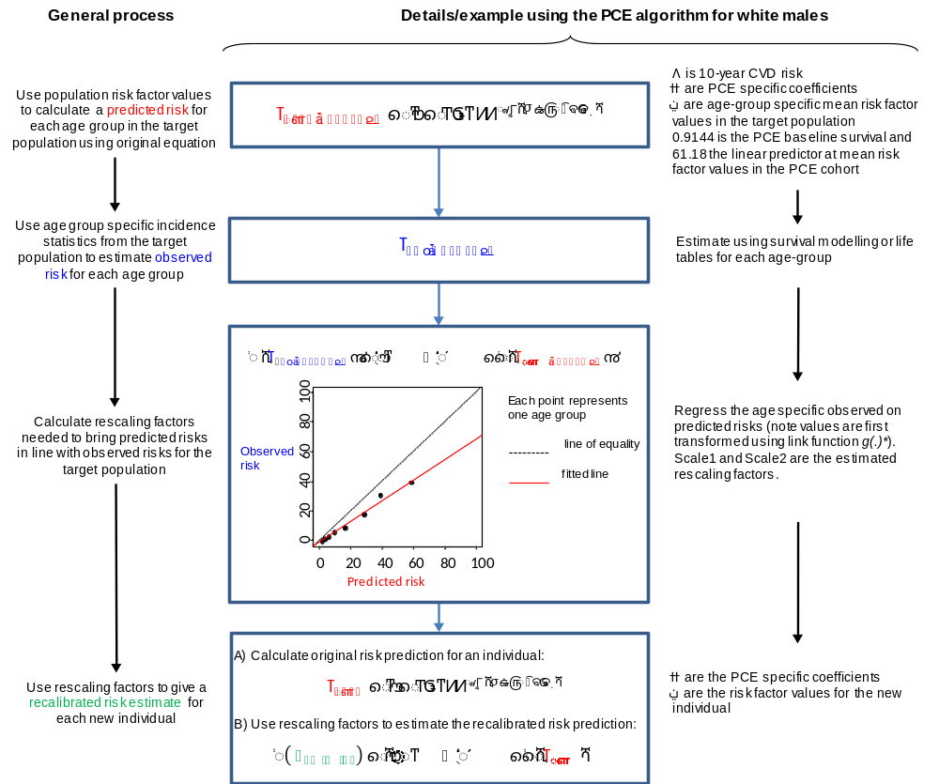

*
PCE: Pooled cohort equations
eFigure 2. Discrimination abilities of original versions of three risk prediction algorithms compared with the Framingham risk score, by sex and geographical region.
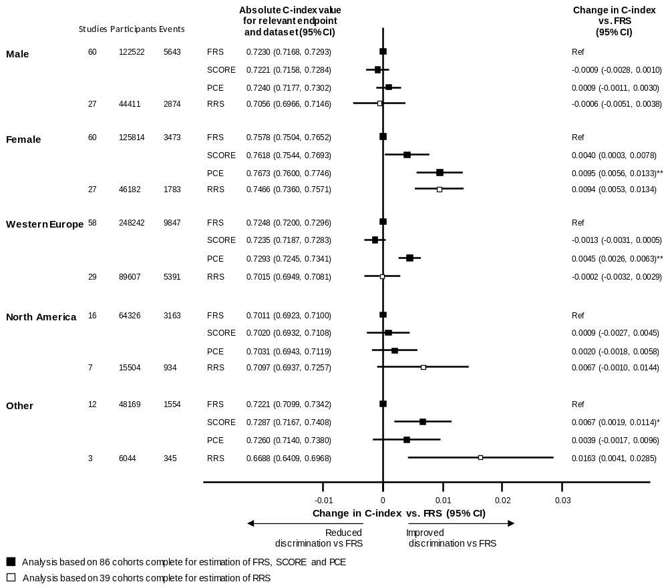

FRS: Framingham risk score; PCE: Pooled cohort equations; SCORE: Systematic COronary Risk Evaluation; RRS: Reynolds Risk Score.
Indicates p<0.05; ** indicates p<0.001

eFigure 3. Discrimination abilities of original versions of risk prediction algorithms compared with the Framingham risk score, in the subset of participants with data available on Reynolds Risk Score

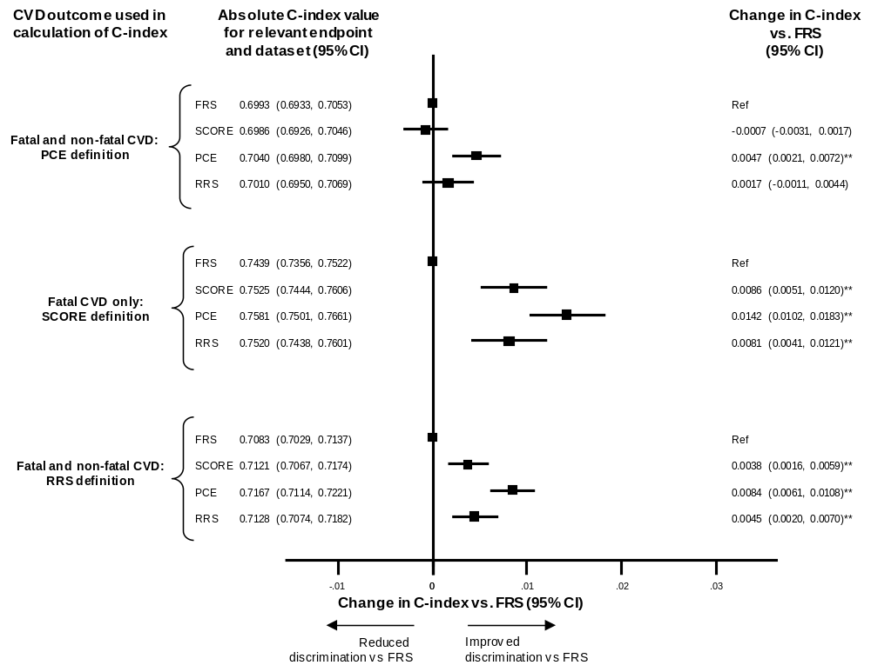

FRS: Framingham risk score; PCE: Pooled cohort equations; SCORE: Systematic COronary Risk Evaluation; RRS: Reynolds Risk Score.
Analysis using the PCE endpoint was based on 39 cohorts, 111155 participants and 6670 events.
Analysis using the SCORE endpoint was based on 39 cohorts, 114075 participants and 2966 events.
Analysis using the RRS endpoint was based on 39 cohorts, 98784 participants and 7953 events.
* Indicates p<0.05; ** indicates p<0.001

eFigure 4. C-index by median baseline year of recruitment

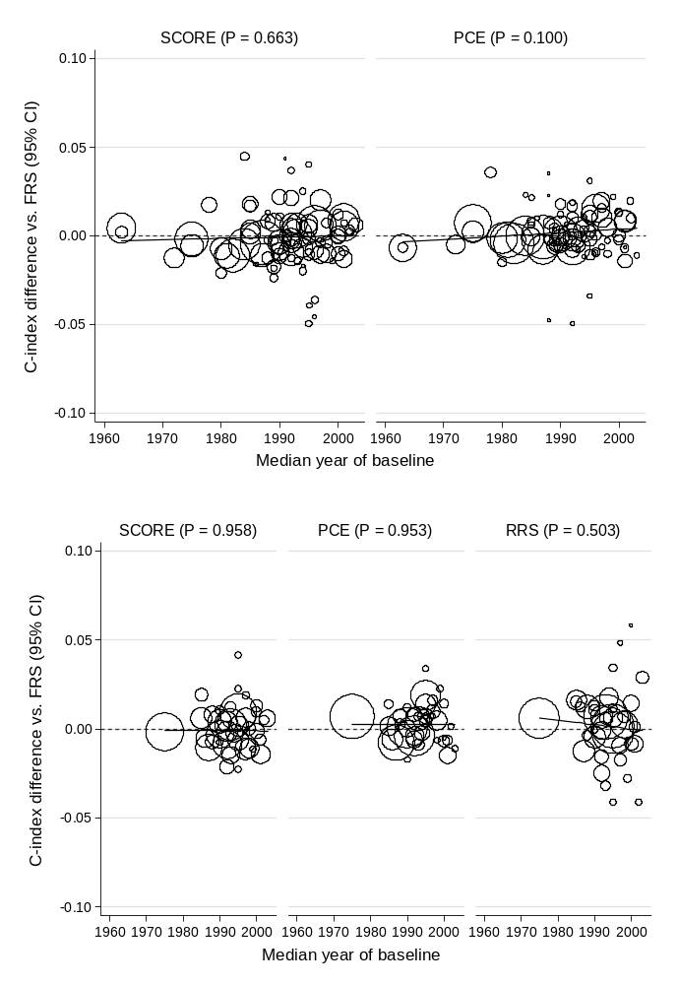

FRS: Framingham risk score; PCE: Pooled cohort equations; SCORE: Systematic COronary Risk Evaluation; RRS: Reynolds risk score.
P-value given is for the null hypothesis that there is no trend in C-index difference with calendar year.

eFigure 5. Observed and predicted 10-year cardiovascular risk using original versions of prediction algorithms, in the subset of participants with data available on Reynolds Risk Score

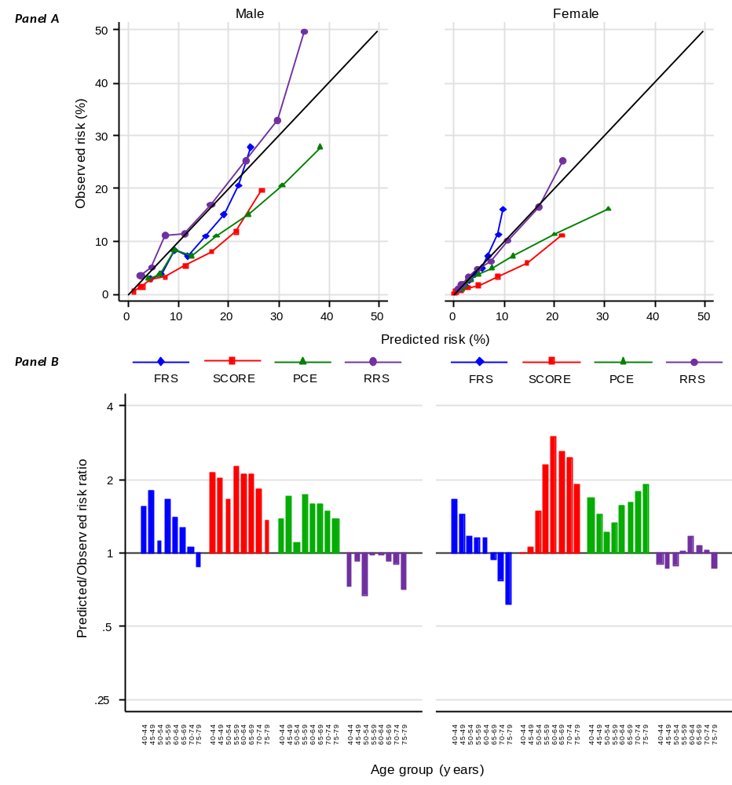

FRS: Framingham risk score; PCE: Pooled cohort equations; SCORE: Systematic COronary Risk Evaluation; RRS: Reynolds Risk Score CVD is defined specifically for each algorithm as per eTable 2. Analysis was based on 88137 participants from 26 cohorts with at least 10-years of follow-up. Points presented in panel A are for each 5 year age group between 40-44 to 75-79 years.

eFigure 6: Observed and predicted CVD risk and the absolute difference between them, by age and sex
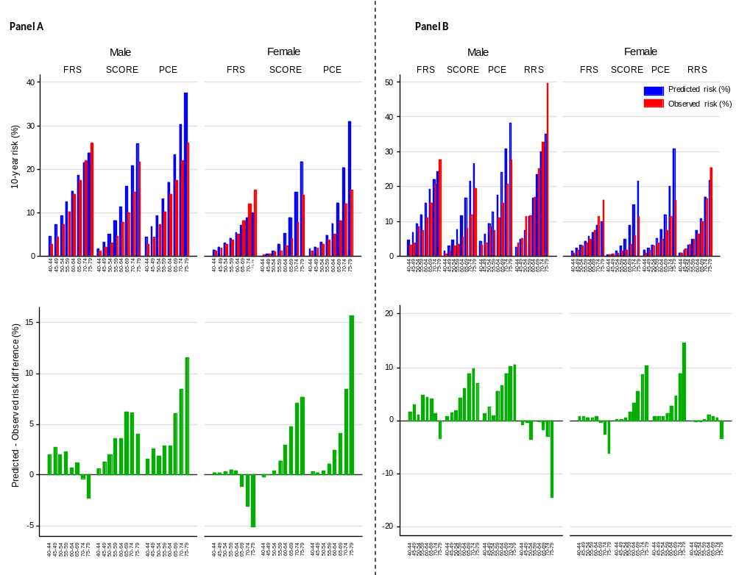

Panel A: Analysis of FRS, SCORE and PCE, based on 220683 participants from 46 cohorts with at least 10-years of follow-up.
Panel B: Analysis of FRS, SCORE, PCE and RRS was based on 88137 participants from 26 cohorts with at least 10-years of follow-up.

eFigure 7. Heterogeneity among studies and algorithms in degree of mis-calibration: study specific ratio of predicted/observed 10-year CVD risk using original versions of each algorithm, plotted against study specific observed risk, by sex
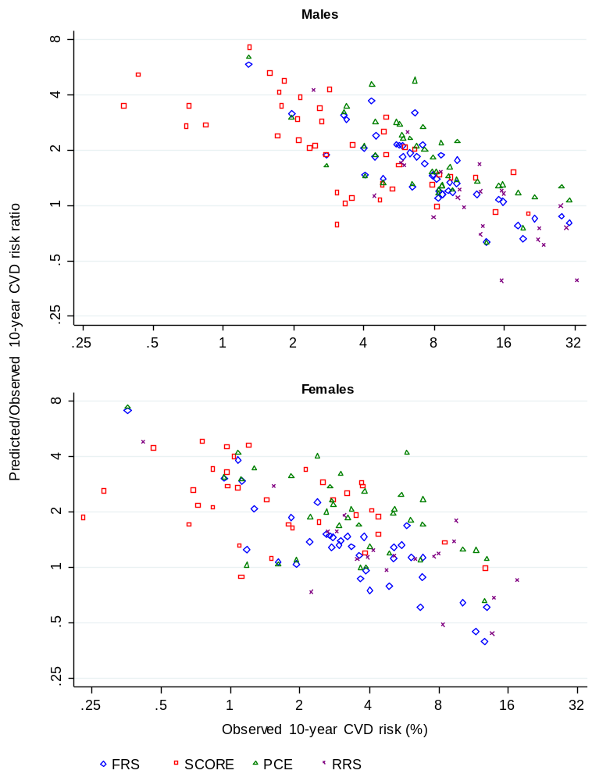

FRS: Framingham risk score; PCE: Pooled cohort equations; SCORE: Systematic COronary Risk Evaluation; RRS: Reynolds Risk Score. CVD includes fatal CHD, fatal and non-fatal MI and any stroke. CVD is defined specifically for each algorithm as per eTable 2.

eFigure 8. Study specific observed and predicted 10-year cardiovascular risk using original version of prediction algorithms
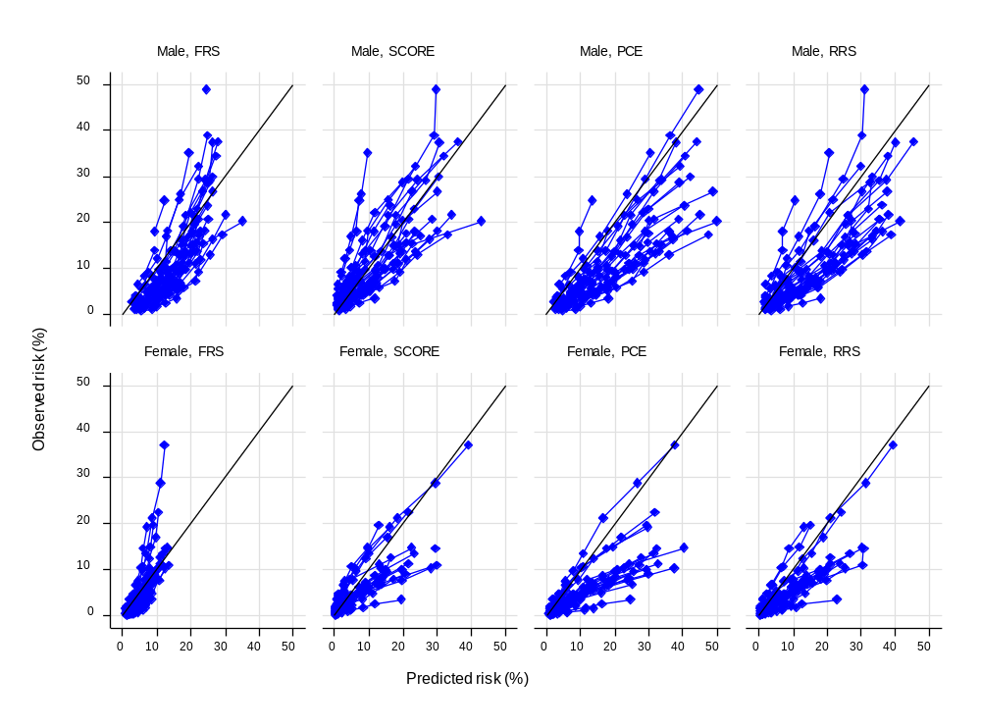
eFigure 9. Study specific ratio of predicted/observed 10-year CVD risk by sex, geographical region and year of baseline screening.
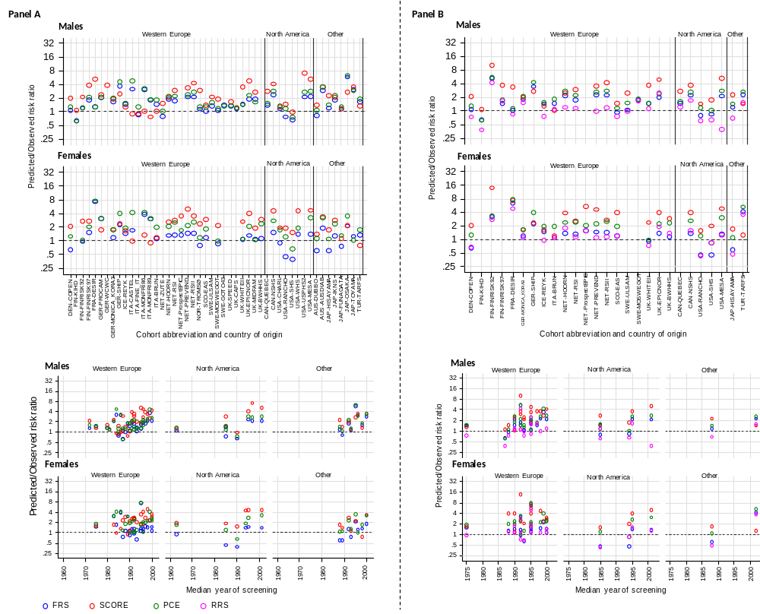
FRS: Framingham risk score; PCE: Pooled cohort equations; SCORE: Systematic COronary Risk Evaluation; RRS: Reynolds Risk Score. CVD includes fatal CHD, fatal and non-fatal MI and any stroke
Panel A: Analysis of FRS, SCORE and PCE was based on 220683 participants from 46 cohorts with at least 10-years of follow-up.
Panel B: Analysis of RRS was based on 88137 participants from 26 cohorts with at least 10-years of follow-up.
eFigure 10: Distribution of 10-year predicted CVD risk before and after recalibration

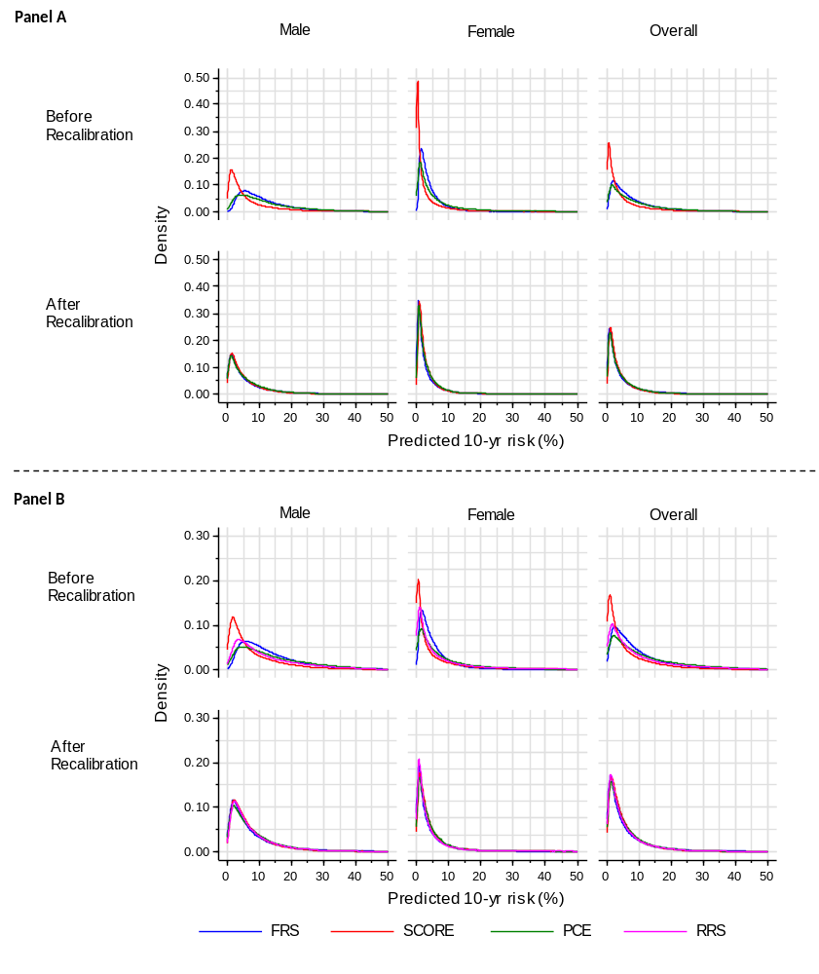

FRS: Framingham risk score; PCE: Pooled cohort equations; SCORE: Systematic COronary Risk Evaluation; Reynolds: Reynolds risk score
Panel A: Analysis of FRS, SCORE and PCE was based on 220683 participants from 46 cohorts with at least 10-years of follow-up.
Panel B: Analysis of FRS, SCORE, PCE and RRS was based on 88137 participants from 26 cohorts with at least 10-years of follow-up.
eFigure 11: Observed and predicted 10-year cardiovascular risk after recalibration to risk factor profile and common CVD endpoint

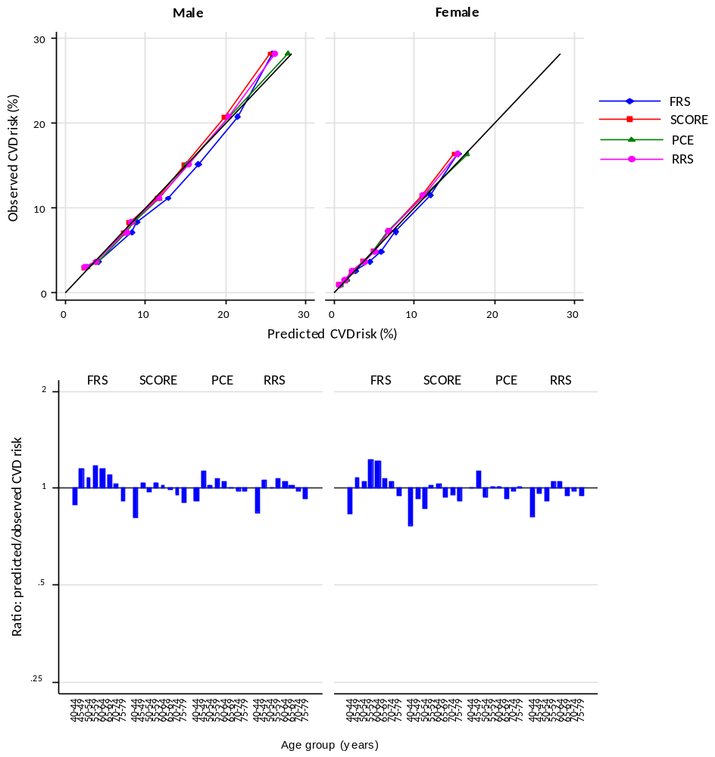

Analysis of FRS, SCORE and PCE was based on 220683 participants from 46 cohorts with at least 10-years of follow-up.
Analysis of RRS was based on 88137 participants from 26 cohorts with at least 10-years of follow-up.

eFigure 12. Overlap in those classified as high risk according when applying all four CVD risk prediction algorithms to a US standard population of 100,000 individuals

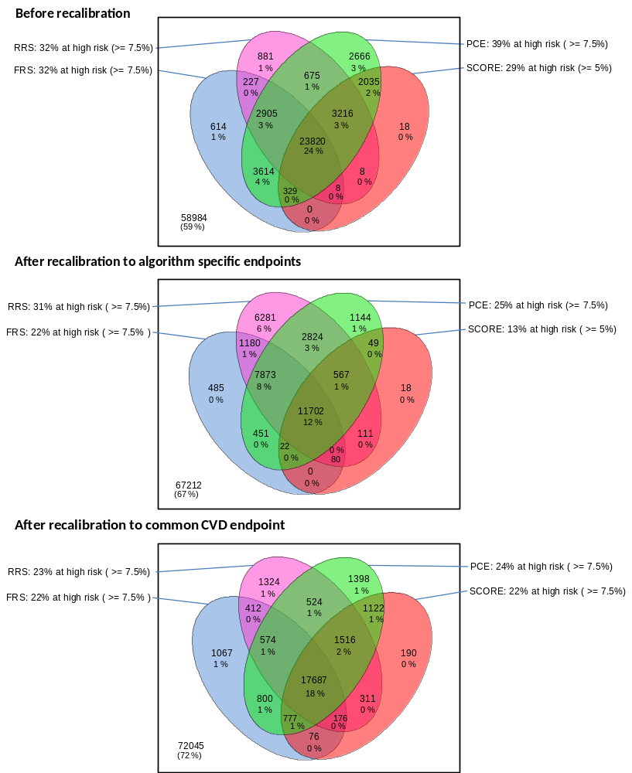

FRS: Framingham risk score; PCE: Pooled cohort equations; SCORE: Systematic COronary Risk Evaluation; RRS: Reynolds risk score. Risk thresholds to define high risk were set at 7.5% for FRS, PCE and RRS and 5% for SCORE before recalibration and after recalibration to the algorithm specific CVD endpoints to reflect the advice of relevant guidelines. After to recalibration to our primary CVD endpoint a risk threshold of 7.5% was used for all algorithms.

eFigure 13. Similarity in individual risk predictions with different scores before and after re-calibration

